|  |
| --- |
| C:\Users\Tsubaki Yukino\Desktop\FlyAwayPlus Project\Capture.JPG |
| **FLY AWAY PLUS** |
| **Software Requirement Specification** |
|  |
| |  |  |  | | --- | --- | --- | | **Fly Away Plus** | | | | **Group Members** | Hoàng Nghĩa Đức | SE02882 | | Dương Thanh Hải | SE02856 | | Nguyễn Minh Hoàng | SE02819 | | Trần Mạnh Hiếu | SE02778 | | Phan Tiến Lực | SE02923 | | Lê Minh Thúy | SE02881 | | **Supervisor** | Mr. Nguyễn Văn Sang | | | **Project code** | FAP | | |
|  |

**- Hanoi, 05/2015 –**

**RECORD OF CHANGE**

*A-Added; M-Modified; D-Deleted

|  |  |  |  |  |
| --- | --- | --- | --- | --- |
| **Effective Date** | **Change Items** | **A*M, D** | **Change Description** | **New Version** |
| 2015/05/29 | Functional Requirement | M |  | v1.0 |
| Non-functional Requirement | M |  |
| 2015/06/11 | Use Case | M | Add new functions | v1.1 |
| Business Rules | M | Add new rules |
| Entity Relationship Diagram | M |  |
| Entity Detail | M |  |
|  |  |  |  |  |
|  |  |  |  |  |
|  |  |  |  |  |

*Table 1: Record of change*

**SIGNATURE PAGE**

|  |  |  |
| --- | --- | --- |
| **ORIGINATOR** | Trần Mạnh Hiếu |  |
|  | Developer |  |
|  |  |  |
|  |  |  |
| **REVIEWERS** | Lê Minh Thúy |  |
|  | Developer |  |
|  |  |  |
|  |  |  |
| **APPROVAL** | Nguyễn Văn Sang |  |
|  | Supervisor |  |
|  |  |  |

Table of Contents

**1.** **INTRODUCTION** 8

1.1. Purpose 8

1.2. Definitions and Acronyms 8

1.3. System Purpose 8

**2.** **OVERALL DESCRIPTION** 9

2.1. System overview 9

2.1.1. Product Features 9

2.1.2. User Characteristics 12

2.1.3. User Documentation 13

2.1.4. Assumption 13

2.2. Entity Relation Model 13

2.2.1. Entity-Relationship Diagram 13

2.2.2. Entity Detail 13

2.2.2.1. Place 13

2.2.2.2. Chat 13

2.2.2.3. Room 14

2.2.2.4. Post 14

2.2.2.5. Picture 14

2.2.2.6. Video 15

2.2.2.7. Comment 15

2.2.2.8. User 15

**3.** **FUNCTIONAL SPECIFICATION** 17

3.1. Use Case Diagram 17

3.2. Business Rules 18

3.3. Use Cases 19

3.3.1. Common Module 19

3.3.1.1. Search 19

*3.3.1.1.1.* *Use-case Diagram* 19

*3.3.1.1.2.* *User-case Specification* 19

Search 19

3.3.1.2. Help Center 20

*3.3.1.2.1.* *Use-case Diagram* 20

*3.3.1.2.2.* *User-case Specification* 20

Send question 21

Basic Guide 21

Search Question 22

3.3.2. Suggest Module 23

Suggest place 23

Suggest friend 24

Suggest activity 24

Look around 25

3.3.3. Social Module 26

3.3.3.1. Personal Page 26

*3.3.3.1.1.* *Use-case Diagram* 26

*3.3.3.1.2.* *User-case Specification* 26

Display Timeline 26

Display News feed 27

3.3.3.2. Post management 28

*3.3.3.2.1.* *Use-case Diagram* 28

*3.3.3.2.2.* *User-case Specification* 28

Add Post 28

Edit Post 29

Delete Post 30

3.3.3.3. Photo management 32

*3.3.3.3.1.* *Use-case Diagram* 32

*3.3.3.3.2.* *User-case Specification* 32

Add Photo 32

Edit Photo Caption 33

Delete Photo 35

3.3.3.4. Video management 35

*3.3.3.4.1.* *Use-case Diagram* 35

*3.3.3.4.2.* *User-case Specification* 35

Add Video 36

Edit Video Caption 37

Delete Video 38

3.3.3.5. Share 39

*3.3.3.5.1.* *Use-case Diagram* 39

*3.3.3.5.2.* *User-case Specification* 39

Share Post 39

Delete Shared Post 40

3.3.3.6. Comment 42

*3.3.3.6.1.* *Use-case Diagram* 42

*3.3.3.6.2.* *User-case Specification* 42

Add Comment 42

Edit Comment 43

Delete Comment 44

3.3.3.7. Like 45

*3.3.3.7.1.* *Use-case Diagram* 45

*3.3.3.7.2.* *User-case Specification* 45

Like 45

Unlike 46

Dislike 47

Un-dislike 47

3.3.3.8. Report 49

*3.3.3.8.1.* *Use-case Diagram* 49

*3.3.3.8.2.* *User-case Specification* 49

Report a post 49

Report a user 50

3.3.3.9. Chat 52

*3.3.3.9.1.* *Use-case Diagram* 52

*3.3.3.9.2.* *User-case Specification* 52

Chat with Friends 52

3.3.3.10. Friend management 53

*3.3.3.10.1.* *Use-case Diagram* 53

*3.3.3.10.2.* *User-case Specification* 53

Add Friend 53

Edit Relationship 54

Unfriend 56

Block 56

Tag Friend on Post 57

Follow 58

3.3.3.11. Room 60

*3.3.3.11.1.* *Use-case Diagram* 60

*3.3.3.11.2.* *User-case Specification* 60

Join room 60

Leave room 62

Create room 62

Edit room’s information 63

Create plan/schedule 64

Edit plan/schedule 66

Add member 67

Update schedule status 68

Remove member 68

Chat 69

3.3.4. Account Management Module 70

3.3.4.1. Login 71

Login by social network’s account/ registered account 71

3.3.4.2. Logout 72

3.3.4.3. Register 73

3.3.4.4. Edit profile 74

3.3.4.5. Forgot password 75

3.3.5. Admin Module 77

3.3.5.1. Lock user’s account 77

3.3.5.2. Unlock user’s account 78

3.3.5.3. Send warning 79

3.3.5.4. Review user 80

3.3.5.5. Review post 82

3.3.5.6. Delete user’s post 83

3.3.5.7. Reply question 84

**4.** **NON-FUNCTIONAL SPECIFICATION** 85

Reliability 85

Performance Requirements 85

User Interface 85

Maintainability 86

Usability 86

Security Requirements 86

Hardware/Software Requirements 86

# **INTRODUCTION**

## Purpose

This is the Software Requirements Specification for the FAP system. This document will provide the describing of general requirement and non-functional requirements of our FAP system. The FAP is designed to be a website that help users sharing their journey and connecting to their friends. These requirements will assure that the system will correctly and reliably perform its intended functionality. This specification will provide general, as well as specific requirements to be used in the design, testing and validation of the system. It is intended for both stakeholders and the project team of the system.

## Definitions and Acronyms

This section describes the definitions, terms, and acronyms that are used in software requirements specification.

|  |  |  |
| --- | --- | --- |
| **Acronym** | **Definition** | **Note** |
| FAP | Fly Away Project |  |

*Table 1-3: Definition and Acronyms*

## System Purpose

Our project – FAP will include some main functions of existing social networks and add some new features such as create room, connect user’s trips as a journey of their life. With the slogan “Share all we have!” we toward on sharing information and experiences between users and spread the joy of travelling together. People can make new friends by join in groups, Fly Away Plus and have new experiences together. We hope we can share all we have, and we hope people who loves travelling can be connected and easily share information about their trips.

# **OVERALL DESCRIPTION**

## System overview

### Product Features

|  |  |  |  |
| --- | --- | --- | --- |
| **UC No.** | **Group of functions** | **Functions** | **Glossary** |
| **FAP GUEST/MEMBER MODULE** | | | |
| **Common Module** | | | |
|  | Search | Search by name | Tìm kiếm những thông tin đang có trên FAP |
|  | Help Center | Send question | Người dùng gửi các câu hỏi liên quan đến FAP |
|  | Basic guide | Hướng dẫn sử dụng cơ bản hệ thống FAP |
|  | Search question | Người dùng có thể tìm kiếm hướng dẫn sử dụng qua các câu hỏi thông thường |
| **FAP MEMBER MODULE** | | | |
| **Suggest Module** | | | |
|  | Suggest | Suggest place | Gợi ý những địa điểm nằm trong xu hướng mới nhất trên FAP |
|  | Suggest friend | Gợi ý kết bạn với những người dùng có nhiều bạn chung/thông tin chung |
|  | Suggest activity | Gợi ý những hoạt động đang là trào lưu hoặc những hoạt động có bạn bè đang tham gia |
|  | Look around | Gợi ý những bài viết được chú ý nhất quanh địa điểm hiện tại của người dùng |
| **Social Module** | | | |
|  | Personal Page | Display timeline | Hiển thị các bài viết và ảnh của người dùng trên một dòng thời gian |
|  | Display news feed | Hiển thị các bài viết của bạn bè và các gợi ý cho các địa điểm/hoạt động v.v… |
|  | Post management | Add post | Thêm bài viết mới |
|  | Edit post | Chỉnh sửa bài viết đã tồn tại |
|  | Delete post | Xóa bài viết đã tồn tại và tất cả những nội dung liên quan |
|  | Photo management | Add photo | Thêm ảnh mới |
|  | Edit photo caption | Chỉnh sửa tiêu đề của một ảnh đã được đăng |
|  | Delete photo | Xóa một ảnh và toàn bộ nội dung liên quan |
|  | Video management | Add video | Thêm video mới |
|  | Edit video caption | Chỉnh sửa tiêu đề của một video đã được đăng |
|  | Delete video | Xóa một video và toàn bộ nội dung liên quan |
|  | Share management | Share post | Chia sẻ một bài viết của một người dùng khác |
|  | Delete shared post | Xóa bài chia sẻ |
|  | Comment management | Add comment | Thêm một bình luận vào bài đăng hoặc ảnh |
|  | Edit comment | Chỉnh sửa một bình luận |
|  | Delete comment | Xóa một bình luận |
|  | Like management | Like | Thích một bài đăng/ảnh |
|  | Unlike | Bỏ thích một bài đăng/ảnh |
|  | Dislike | Không thích một bài đăng/ảnh |
|  | Un-dislike | Bỏ không thích một bài đăng/ảnh |
|  | Report | Report a post | Báo cáo một bài đăng có nội dung vi phạm tới quản trị viên |
|  | Report an user | Báo cáo một người dùng có hành vi vi phạm tới quản trị viên |
|  | Chat | Chat with others | Tán gẫu với người dùng khác |
|  | Friend management | Add friend | Kết bạn với thành viên khác |
|  | Edit relationship | Chỉnh sửa mối quan hệ với thành viên đã là bạn |
|  | Unfriend | Hủy kết bạn với một thành viên |
|  | Block | Chặn người dùng khác |
|  | Tag friend | Tag bạn bè vào bài đăng/ảnh |
|  | Follow user | Theo dõi người dùng khác để có thể nhìn thấy bài đăng và hình ảnh ở chế độ cộng đồng mà không trở thành bạn |
|  | Room | Join room | Tham gia vào một phòng |
|  | Leave room | Thoát khỏi một phòng đã tham gia |
|  | Create room | Tạo một phòng |
|  | Edit room’s information | Chỉnh sửa thông tin một phòng đã tạo |
|  | Create plan/schedule | Tạo kế hoạch/lịch trình cho một chuyến đi trong phòng |
|  | Edit plan/schedule | Chỉnh sửa kế hoạch/lịch trình cho một chuyến đi trong phòng |
|  | Add member | Thêm thành viên mới vào phòng |
|  | Remove member | Mời một thành viên ra khỏi phòng |
|  | Update schedule status | Cập nhật lịch trình |
|  | Chat | Tán gẫu với thành viên phòng |
| **Account Management Module** | | | |
|  | Login | Login by social network’s account | Đăng nhập bằng tài khoản Facebook/Google |
| Login by registered account | Đăng nhập bằng tài khoản được đăng ký trên FAP |
|  |  | Logout | Đăng xuất |
|  |  | Register | Đăng ký thành viên để sử dụng tất cả các chức năng của FAP |
|  |  | Edit Profile | Chỉnh sửa thông tin cá nhân |
|  |  | Forgot Password | Yêu cầu hệ thống giúp đỡ khi quên mật khẩu |
| **FAP ADMIN MODULE** | | | |
|  | Management Member’s account | Lock user’s account | Khóa tài khoản của người dùng vi phạm |
|  | Unlock user’s account | Mở khóa tài khoản người dùng |
|  | Send warning | Gửi cảnh báo đến người dùng |
|  | Review user | Kiểm tra một người dùng bị báo cáo vi phạm |
|  | Review post | Kiểm tra một bài post bị báo cáo vi phạm |
|  | Delete post | Xóa một bài post có nội dung vi phạm |
|  | Reply question | Trả lời câu hỏi của người dùng gửi đến |

### User Characteristics

This website developed towards those who love travel, looking for a website to share about their trips, searching for information, review of places, searching for friends for new trips and keep in touch with their fellow traveler. There are three main actors that system support:

* **Guest:** Do not have account on system. In general, they can use common features (search a place, search food and drinks, search on maps) and register feature.
* **Member:** Have account on system, they can use all functions of website. For example: Searching, posting, connect to friends etc…
* **Administrator:** They can use all functions of normal member and have an Administrator control panel to manage all configuration of system.

### User Documentation

|  |  |
| --- | --- |
| **Name** | **Description** |
| User Manual | Provide detailed explanation about the system, screens and guide users how to use all features of FAP website. |

### Assumption

* Receive the guidance and good support of teacher.
* No one of member got sick in the software development process.
* In the development process, no device got fail.
* Every report meets the deadline.
* Team member do not conflict in the work process.

## Entity Relation Model

### Entity-Relationship Diagram



### Entity Detail

### Place

|  |  |  |  |  |
| --- | --- | --- | --- | --- |
| No | Field Name | Type | Mandatory | Description |
|  | place_id | Number | Y | Place’s id |
|  | longitude | Number | Y | Place’s longitude |
|  | latitude | Number | Y | Place’s latitude |

### Chat

|  |  |  |  |  |
| --- | --- | --- | --- | --- |
| No | Field Name | Type | Mandatory | Description |
|  | chat_id | Number | Y | Chat’s id |
|  | content | String | Y | Chat’s content |
|  | date_created | Date | Y | Chat’s date created |

### Room

|  |  |  |  |  |
| --- | --- | --- | --- | --- |
| No | Field Name | Type | Mandatory | Description |
|  | room_id | Number | Y | Room’s id |
|  | room_name | String | Y | Room’s name |
|  | date_created | Date | Y | Room’s date created |

### Post

|  |  |  |  |  |
| --- | --- | --- | --- | --- |
| No | Field Name | Type | Mandatory | Description |
|  | post_id | Number | Y | Post’s id |
|  | content | String | Y | Post’s content |
|  | date_created | String | Y | Post’s date created |

### Picture

|  |  |  |  |  |
| --- | --- | --- | --- | --- |
| No | Field Name | Type | Default | Description |
|  | picture_id | Number | Y | Picture’s id |
|  | path | String | Y | Picture’s path |
|  | date_created | Date | Y | Picture’s date created |

### Video

|  |  |  |  |  |
| --- | --- | --- | --- | --- |
| No | Field Name | Type | Mandatory | Description |
|  | video_id | Number | Y | Video’s id |
|  | path | String | Y | Video’s path |
|  | date_created | Date | Y | Video’s date created |

### Comment

|  |  |  |  |  |
| --- | --- | --- | --- | --- |
| No | Field Name | Type | Mandatory | Description |
|  | comment_id | Number | Y | Comment’s id |
|  | content | String | Y | Comment’s content |
|  | date_created | Date | Y | Comment’s date created |

### User

|  |  |  |  |  |
| --- | --- | --- | --- | --- |
| No | Field Name | Type | Mandatory | Description |
|  | user_id | Number | Y | User’s id |
|  | first_name | String | Y | User’s first name |
|  | last_name | String | Y | User’s last name |
|  | email | String | Y | User’s email |
|  | password | String | Y | User’s password |
|  | address | String | Y | User’s address |
|  | genre | String | Y | User’s genre |
|  | phone_number | String |  | User’s phone number |
|  | date_of_birth | Date | Y | User’s date of birth |
|  | username | String | Y | User’s username |
|  | status | String | Y | User’s status |
|  | date_joined | Date | Y | User’s date joined |
|  | type | String | Y | User’s type |

# **FUNCTIONAL SPECIFICATION**

## Use Case Diagram

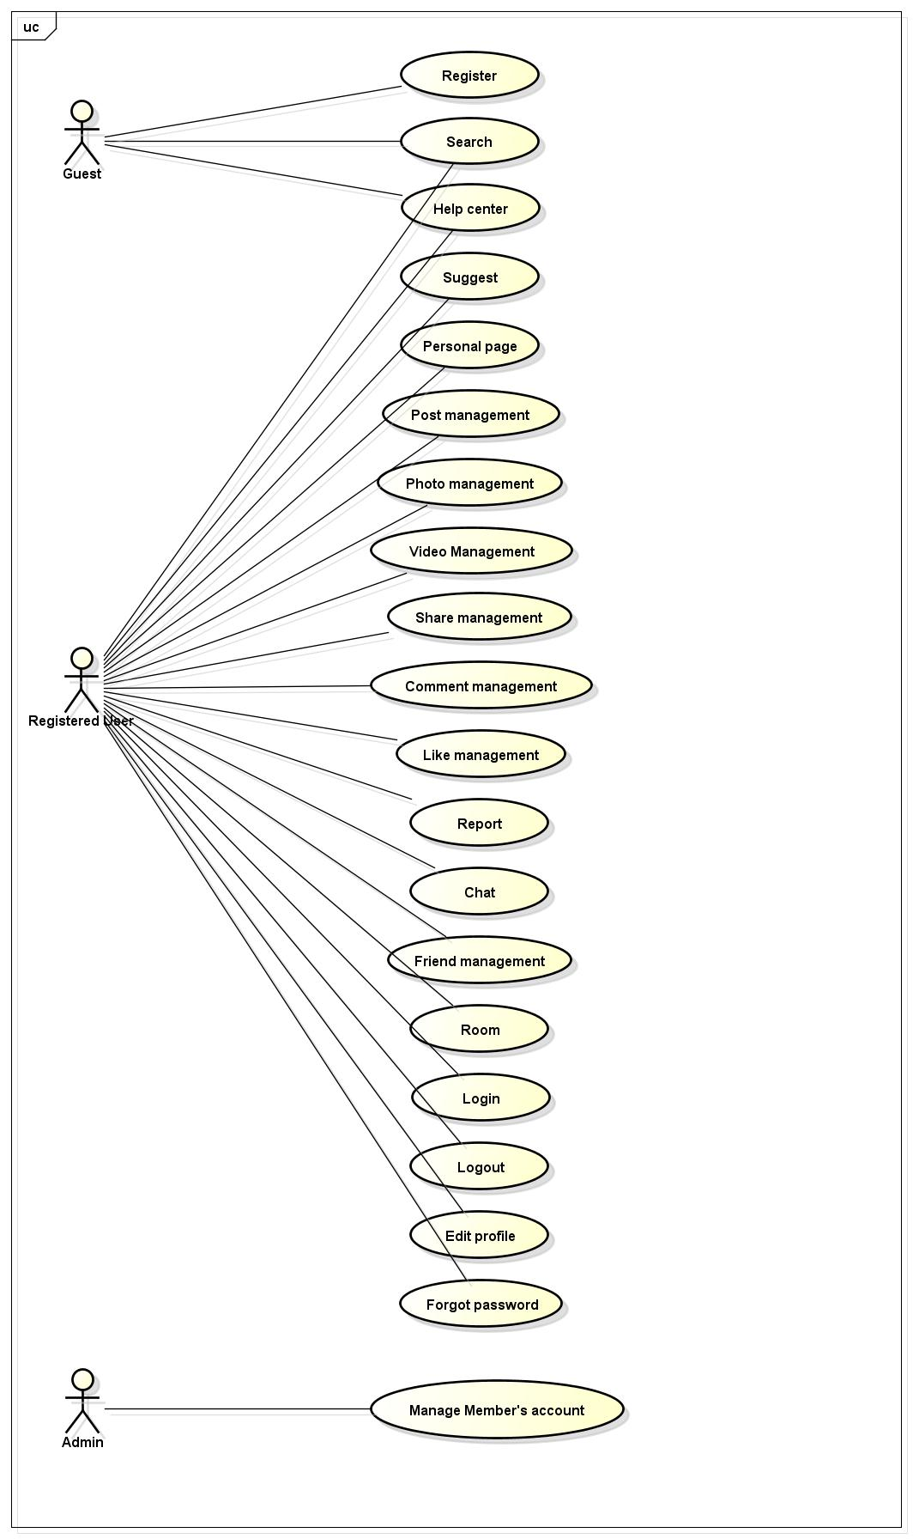

Figure 3-1: Use case diagram of FAP system

## Business Rules

|  |  |
| --- | --- |
| **No** | **Description** |
|  | Search textbox cannot be empty |
|  | Subject cannot be empty |
|  | Content cannot be empty |
|  | Subject is limited to xxx characters |
|  | Content is limited to xxx characters |
|  | Allowed file extension: .jpg, .png, .bmp |
|  | File size is limited to xxx MB |
|  | Comment is limited to xxx characters |
|  | If user choose Others, textbox cannot be empty |
|  | Chat box cannot be empty |
|  | Friend must be chosen, cannot be entered |
|  | Name cannot be empty |
|  | Place must be chosen |
|  | Start date and end date must be chosen |
|  | Milestones must be chosen |
|  | Post lazy loading technique displays at most 10 more each time |
|  | If user accesses to nonexistent page, FAP displays error message “Page not found” |
|  | User name must be at least xxx characters |
|  | Password must be at least xxx characters |
|  | Password cannot be same as user name |
|  | Email must content characters ‘@’ and ‘.’ |
|  | Date of birth must be chosen |
|  | Phone number must be number phrase |
|  | Locked user cannot comment |
|  | Locked user cannot create post |
|  | Information of each item in friend list includes: avatar (profile picture), friend name, “User” menu |
|  | Friend request has 3 states: “pending”, “accepted”, “declined” |
|  | The target user must be available, not locked or deleted |
|  | User mouse over menu includes: avatar (profile picture), user name, “User” menu |
|  | Room’s privacy is default set to Public |
|  | Milestones default status is Not passed |

## Use Cases

## Common Module

## Search

## *Use-case Diagram*

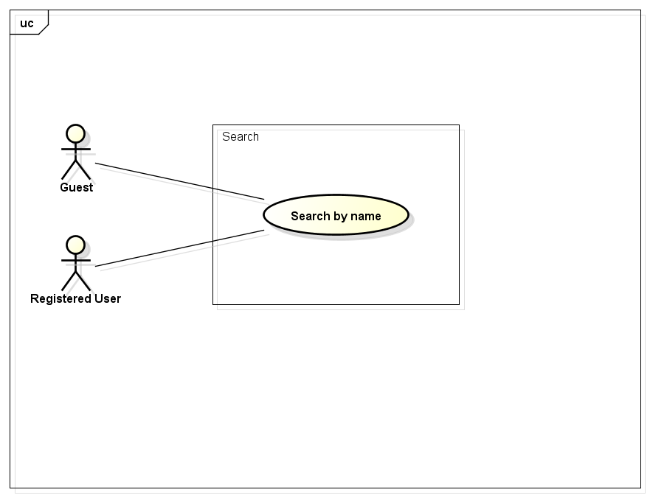

## *User-case Specification*

### Search

|  |  |  |  |  |
| --- | --- | --- | --- | --- |
| **Use Case ID** | | UC001 | **Version** | 1.1 |
| **Use Case Name** | | Search by name | | |
| **Created by:** | | HieuTM | **Date Created:** | 28/05/2015 |
| **Primary Actor** | | Registered user | **Secondary Actor** | Guest |
| **Description:** | | This function allows user to search existing information stored on FAP by a phrase (name of places, food and drinks, activities, friends…) | | |
| **Preconditions:** | | 1. FAP website is available 2. User browsed FAP website | | |
| **Trigger:** | | Application runs normally and displays Homepage | | |
| **Post conditions:** | | List all results that matched with the keyword user enters will be displayed in the Search Details screen | | |
| **Normal Flow** | | | | |
| **Step** | **Actor** | **Action** | | |
| 1 | User | Enter search phrase to text box. | | |
| 2 | User | Click Search or press Enter | | |
| 3 | FAP | Redirect to Search Result screen | | |
| 4 | FAP | List all results that matched with the keyword user entered | | |
| **Alternative Flows: N/A** | | | | |
| **Exceptions:** | | | | |
| **EC1** | The connection is terminated | | | |
| **Step** | **Actor** | **Action** | | |
| 1 | FAP | All fields are cleared and FAP return to the wait state. | | |
|  | | | | |
| **EC2** | At step 4 in the main flows, if there is no result matched the keywords | | | |
| **Step** | **Actor** | **Action** | | |
| 4.1 | FAP | Display Search Results screen with text: “Nothing found :(” | | |
|  | | | | |
| **Priority** | | High | | |
| **Frequency of Use:** | | High | | |
| **Business Rules:** | |  | | |
| **Other Information:** | | N/A | | |

## Help Center

## *Use-case Diagram*

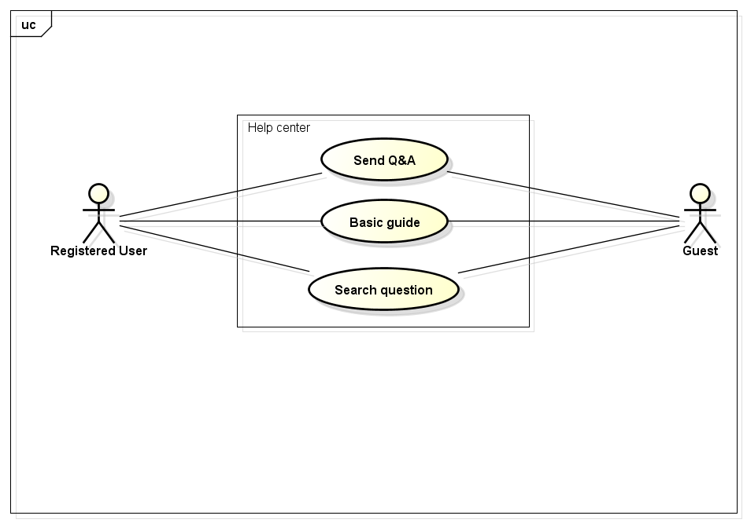

## *User-case Specification*

### Send question

|  |  |  |  |  |
| --- | --- | --- | --- | --- |
| **Use Case ID** | | UC002 | **Version** | 1.1 |
| **Use Case Name** | | Send question | | |
| **Created by:** | | HieuTM | **Date Created:** | 06/09/2015 |
| **Primary Actor** | | Registered user | **Secondary Actor** | Guest |
| **Description:** | | This function allows user to send questions, ideas, opinions to admin. | | |
| **Preconditions:** | | 1. FAP website is available 2. User browsed FAP website | | |
| **Trigger:** | | User want to send questions, ideas, opinions about FAP website. | | |
| **Post conditions:** | | 1. Message is displayed 2. User’s content is sent to admin | | |
| **Normal Flow** | | | | |
| **Step** | **Actor** | **Action** | | |
| 1 | User | Click Q&A in FAP website footer | | |
| 2 | FAP | Display Q&A Form | | |
| 3 | User | Enter required fields | | |
| 4 | User | Click Send or press Enter | | |
| 5 | FAP | Display message: “Your Q&A is sent” | | |
| 6 | FAP | Redirect user to previous page | | |
| **Alternative Flows: N/A** | | | | |
| **Exceptions:** | | | | |
| **EC1** | The connection is terminated | | | |
| **Step** | **Actor** | **Action** | | |
| 1 | FAP | All fields are cleared and FAP return to the wait state. | | |
|  | | | | |
| **EC2** | At step 3 in the main flows, if required fields are not entered | | | |
| **Step** | **Actor** | **Action** | | |
| 4.1 | FAP | 1. Display Q&A Form with text: “You have to fill all required fields” 2. Mark all error fields | | |
|  | | | | |
| **Priority** | | Normal | | |
| **Frequency of Use:** | | Normal | | |
| **Business Rules:** | |  | | |
| **Other Information:** | | N/A | | |

### Basic Guide

|  |  |  |  |  |
| --- | --- | --- | --- | --- |
| **Use Case ID** | | UC003 | **Version** | 1.1 |
| **Use Case Name** | | Basic guide | | |
| **Created by:** | | HieuTM | **Date Created:** | 09/06/2015 |
| **Primary Actor** | | Registered user | **Secondary Actor** | Guest |
| **Description:** | | A guide page to let user know how to use FAP website or frequently asked questions. | | |
| **Preconditions:** | | 1. FAP website is available 2. User browsed FAP website | | |
| **Trigger:** | | User want to know how to use FAP website | | |
| **Post conditions:** | | FAP display Basic Guide page | | |
| **Normal Flow** | | | | |
| **Step** | **Actor** | **Action** | | |
| 1 | User | Click Basic Guide in FAP website footer | | |
| 2 | FAP | Redirect user to Basic Guide page | | |
| **Alternative Flows: N/A** | | | | |
| **Exceptions:** | | | | |
| **EC1** | The connection is terminated | | | |
| **Step** | **Actor** | **Action** | | |
| 1 | FAP | Return to wait state | | |
| **Priority** | | Normal | | |
| **Frequency of Use:** | | Normal | | |
| **Business Rules:** | | N/A | | |
| **Other Information:** | | N/A | | |

### Search Question

|  |  |  |  |  |
| --- | --- | --- | --- | --- |
| **Use Case ID** | | UC004 | **Version** | 1.1 |
| **Use Case Name** | | Search question | | |
| **Created by:** | | HieuTM | **Date Created:** | 09/06/2015 |
| **Primary Actor** | | Registered user | **Secondary Actor** | Guest |
| **Description:** | | This function allows user to search a question in frequently asked questions list | | |
| **Preconditions:** | | 1. FAP website is available 2. User browsed FAP website 3. User browsed Basic Guide page | | |
| **Trigger:** | | User want to search a question in Basic Guide page | | |
| **Post conditions:** | | Question is displayed | | |
| **Normal Flow** | | | | |
| **Step** | **Actor** | **Action** | | |
| 1 | User | Enter search phrase to text box | | |
| 2 | User | Click Search or press Enter | | |
| 3 | FAP | Scroll to question | | |
| **Alternative Flows: N/A** | | | | |
| **Exceptions:** | | | | |
| **EC1** | The connection is terminated | | | |
| **Step** | **Actor** | **Action** | | |
| 1 | FAP | All fields are cleared and FAP return to the wait state. | | |
|  | | | | |
| **EC2** | At step 3 in the main flows, if there is no result matched the keywords | | | |
| **Step** | **Actor** | **Action** | | |
| 3.1 | FAP | Display Basic Guide page with text: “Nothing found :(” | | |
|  | | | | |
| **Priority** | | Normal | | |
| **Frequency of Use:** | | Normal | | |
| **Business Rules:** | | N/A | | |
| **Other Information:** | | N/A | | |

## Suggest Module

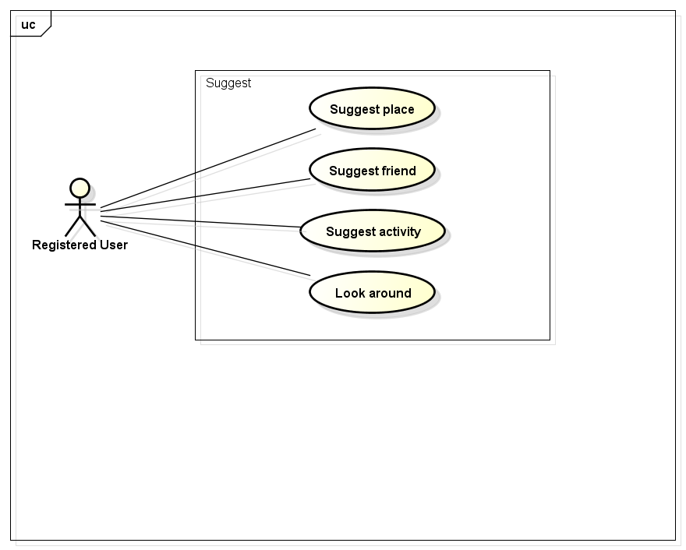

### Suggest place

|  |  |  |  |  |
| --- | --- | --- | --- | --- |
| **Use Case ID** | | UC005 | **Version** | 1.1 |
| **Use Case Name** | | Suggest place | | |
| **Created by:** | | HieuTM | **Date Created:** | 09/06/2015 |
| **Primary Actor** | | Registered user | **Secondary Actor** | N/A |
| **Description:** | | FAP suggests places to user base on users traveled, viewed history, wish list and trends. | | |
| **Preconditions:** | | 1. FAP website is available 2. User browsed FAP website 3. User logged in to system | | |
| **Trigger:** | | N/A | | |
| **Post conditions:** | | 1. Suggests is displayed | | |
| **Normal Flow** | | | | |
| **Step** | **Actor** | **Action** | | |
| 1 | User | Click Place | | |
| 2 | FAP | Display Suggest Place List | | |
| **Alternative Flows: N/A** | | | | |
| **Exceptions: N/A** | | | | |
| **Priority** | | High | | |
| **Frequency of Use:** | | High | | |
| **Business Rules:** | | N/A | | |
| **Other Information:** | | N/A | | |

### Suggest friend

|  |  |  |  |  |
| --- | --- | --- | --- | --- |
| **Use Case ID** | | UC006 | **Version** | 1.1 |
| **Use Case Name** | | Suggest friend | | |
| **Created by:** | | HieuTM | **Date Created:** | 09/06/2015 |
| **Primary Actor** | | Registered user | **Secondary Actor** | N/A |
| **Description:** | | FAP suggests friends to user base on mutual friends, activities or likes | | |
| **Preconditions:** | | 1. FAP website is available 2. User browsed FAP website 3. User logged in to system | | |
| **Trigger:** | | N/A | | |
| **Post conditions:** | | Suggests is displayed | | |
| **Normal Flow** | | | | |
| **Step** | **Actor** | **Action** | | |
| 1 | User | Click Friend | | |
| 2 | FAP | Display Suggest Friend List | | |
| **Alternative Flows: N/A** | | | | |
| **Exceptions: N/A** | | | | |
| **Priority** | | High | | |
| **Frequency of Use:** | | High | | |
| **Business Rules:** | | N/A | | |
| **Other Information:** | | N/A | | |

### Suggest activity

|  |  |  |  |  |
| --- | --- | --- | --- | --- |
| **Use Case ID** | | UC007 | **Version** | 1.1 |
| **Use Case Name** | | Suggest activity | | |
| **Created by:** | | HieuTM | **Date Created:** | 09/06/2015 |
| **Primary Actor** | | Registered user | **Secondary Actor** | N/A |
| **Description:** | | FAP suggests activities to user base on users traveled, viewed history, wish list and trends. | | |
| **Preconditions:** | | 1. FAP website is available 2. User browsed FAP website 3. User logged in to system | | |
| **Trigger:** | | N/A | | |
| **Post conditions:** | | Suggests is displayed | | |
| **Normal Flow** | | | | |
| **Step** | **Actor** | **Action** | | |
| 1 | User | Click Activity | | |
| 2 | FAP | Display Suggest Activity List | | |
| **Alternative Flows: N/A** | | | | |
| **Exceptions: N/A** | | | | |
| **Priority** | | High | | |
| **Frequency of Use:** | | High | | |
| **Business Rules:** | | N/A | | |
| **Other Information:** | | N/A | | |

### Look around

|  |  |  |  |  |
| --- | --- | --- | --- | --- |
| **Use Case ID** | | UC008 | **Version** | 1.1 |
| **Use Case Name** | | Look around | | |
| **Created by:** | | HieuTM | **Date Created:** | 28/05/2015 |
| **Primary Actor** | | Registered user | **Secondary Actor** |  |
| **Description:** | | This function allows user to see activities of others around | | |
| **Preconditions:** | | 1. FAP website is available 2. User browsed FAP website 3. User logged in to system | | |
| **Trigger:** | | User browses FAP website | | |
| **Post conditions:** | | 1. Look Around page is displayed | | |
| **Normal Flow** | | | | |
| **Step** | **Actor** | **Action** | | |
| 1 | User | Click Look Around | | |
| 2 | FAP | Redirect user to Look Around page | | |
| 3 | User | Enter location to text box | | |
| 4 | User | Click Look or press Enter | | |
| 5 | FAP | Display Look Around page with results | | |
| **Alternative Flows** | | | | |
| **AT1** | At step 3 in the main flow, user click Auto-Located | | | |
| **Step** | **Actor** | **Action** | | |
| 3.1 | FAP | Display Look Around page with results | | |
| **Exceptions:** | | | | |
| **EC1** | The connection is terminated | | | |
| **Step** | **Actor** | **Action** | | |
| 1 | FAP | All fields are cleared and FAP return to the wait state. | | |
|  | | | | |
| **EC2** | At step 5 in the main flows, if there is no result matched the keywords | | | |
| **Step** | **Actor** | **Action** | | |
| 5.1 | FAP | Display Look Around page with message: “No location found” | | |
|  | | | | |
| **EC2** | At step 3.1 in the alternative flows, if FAP cannot locate user’s current location | | | |
| **Step** | **Actor** | **Action** | | |
| 3.1 | FAP | Display Look Around page with message: “Cannot Auto-Located” | | |
|  | | | | |
| **Priority** | | Normal | | |
| **Frequency of Use:** | | High | | |
| **Business Rules:** | | N/A | | |
| **Other Information:** | | N/A | | |

## Social Module

## Personal Page

## *Use-case Diagram*

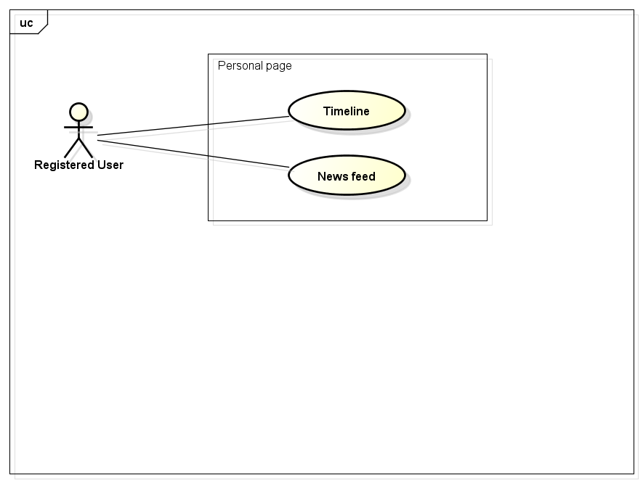

## *User-case Specification*

### Display Timeline

|  |  |  |  |  |
| --- | --- | --- | --- | --- |
| **Use Case ID** | | UC009 | **Version** | 1.1 |
| **Use Case Name** | | Display Timeline | | |
| **Created by:** | | HieuTM | **Date Created:** | 28/05/2015 |
| **Primary Actor** | | Registered user | **Secondary Actor** |  |
| **Description:** | | FAP records all of user’s activities and display in time order | | |
| **Preconditions:** | | 1. FAP website is available 2. User browsed FAP website 3. User logged in to system | | |
| **Trigger:** | | User wants to see history of activities | | |
| **Post conditions:** | | Timeline page is displayed | | |
| **Normal Flow** | | | | |
| **Step** | **Actor** | **Action** | | |
| 1 | User | Click Timeline | | |
| 2 | FAP | Redirect user to Timeline page | | |
| **Alternative Flows: N/A** | | | | |
| **Exceptions:** | | | | |
| **EC1** | The connection is terminated | | | |
| **Step** | **Actor** | **Action** | | |
| 1 | FAP | Return to the wait state. | | |
| **Priority** | | High | | |
| **Frequency of Use:** | | High | | |
| **Business Rules:** | | N/A | | |
| **Other Information:** | | N/A | | |

### Display News feed

|  |  |  |  |  |
| --- | --- | --- | --- | --- |
| **Use Case ID** | | UC010 | **Version** | 1.1 |
| **Use Case Name** | | Display News feed | | |
| **Created by:** | | HieuTM | **Date Created:** | 28/05/2015 |
| **Primary Actor** | | Registered user | **Secondary Actor** |  |
| **Description:** | | FAP updates activities of user’s friends automatically | | |
| **Preconditions:** | | 1. FAP website is available 2. User browsed FAP website 3. User logged in to system | | |
| **Trigger:** | | User wants to see friends’ activity | | |
| **Post conditions:** | | 1. News feed page is displayed | | |
| **Normal Flow** | | | | |
| **Step** | **Actor** | **Action** | | |
| 1 | User | Click News feed | | |
| 2 | FAP | Redirect user to News Feed page | | |
| **Alternative Flows: N/A** | | | | |
| **Exceptions:** | | | | |
| **EC1** | The connection is terminated | | | |
| **Step** | **Actor** | **Action** | | |
| 1 | FAP | Return to the wait state. | | |
|  | | | | |
| **Priority** | | High | | |
| **Frequency of Use:** | | High | | |
| **Business Rules:** | | N/A | | |
| **Other Information:** | | N/A | | |

## Post management

## *Use-case Diagram*

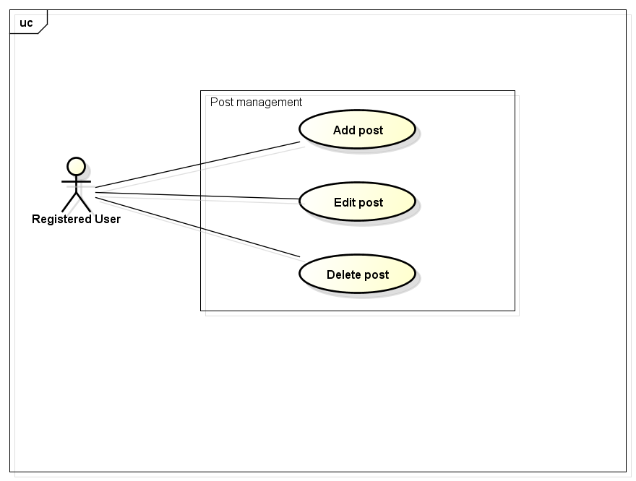

## *User-case Specification*

### Add Post

|  |  |  |  |  |
| --- | --- | --- | --- | --- |
| **Use Case ID** | | UC011 | **Version** | 1.1 |
| **Use Case Name** | | Add post | | |
| **Created by:** | | HieuTM | **Date Created:** | 28/05/2015 |
| **Primary Actor** | | Registered user | **Secondary Actor** | None |
| **Description:** | | This function allows user to share information, knowledge, experience | | |
| **Preconditions:** | | 1. FAP website is available 2. User browsed FAP website 3. User logged in to system | | |
| **Trigger:** | | User wants to share information | | |
| **Post conditions:** | | 1. Post is updated to user’s timeline. 2. Post is updated to News feed of user’s friends. 3. Post is updated to Database. | | |
| **Normal Flow** | | | | |
| **Step** | **Actor** | **Action** | | |
|  | User | Click Create Post. | | |
|  | FAP | Redirects user to Add Post Page which contain a create form. | | |
|  | User | Enter information in fields. | | |
|  | User | Choose privacy | | |
|  | User | Click Create or press Enter. | | |
|  | FAP | Create a post | | |
|  | FAP | Updates to user’s timeline | | |
|  | FAP | Updates to News feed of user’s friends | | |
|  | FAP | Displays message “Post is created” | | |
|  | FAP | Redirects user to Post Page which contain created post. | | |
| **Alternative Flows** | | | | |
| **AT1** | At step 5, user click Cancel | | | |
| **Step** | **Actor** | **Action** | | |
| 5.1 | FAP | FAP redirects user to previous page. | | |
| **Exceptions:** | | | | |
| **EC1** | The connection is terminated | | | |
| **Step** | **Actor** | **Action** | | |
| 1 | FAP | All fields are cleared and FAP return to the wait state. | | |
|  | | | | |
| **EC2** | At step 4, required fields are not entered | | | |
| **Step** | **Actor** | **Action** | | |
| 4.1 | FAP | Display Add Post page with message “Required fields are not entered” | | |
| 4.2 | FAP | Mark error fields | | |
|  | | | | |
| **EC3** | At step 4, fields are entered with wrong type of data | | | |
| **Step** | **Actor** | **Action** | | |
| 4.1 | FAP | Display Add Post page with message “Wrong type of data” | | |
| 4.2 | FAP | Mark error fields | | |
|  | | | | |
| **Priority** | | High | | |
| **Frequency of Use:** | | High | | |
| **Business Rules:** | | N/A | | |
| **Other Information:** | | N/A | | |

### Edit Post

|  |  |  |  |  |
| --- | --- | --- | --- | --- |
| **Use Case ID** | | UC012 | **Version** | 1.1 |
| **Use Case Name** | | Edit post | | |
| **Created by:** | | HieuTM | **Date Created:** | 28/05/2015 |
| **Primary Actor** | | Registered user | **Secondary Actor** | None |
| **Description:** | | This function allows user to edit their post | | |
| **Preconditions:** | | 1. FAP website is available 2. User browsed FAP website 3. User logged in to system 4. User are viewing their own post | | |
| **Trigger:** | | User wants to edit information of their own posts | | |
| **Post conditions:** | | 1. Post is updated to FAP website. 2. Post is updated to User Detail. 3. Post is updated to Database. | | |
| **Normal Flow** | | | | |
| **Step** | **Actor** | **Action** | | |
| 1 | User | Click Edit | | |
| 2 | FAP | Redirects user to Edit Post Page which contain a create form with information is filled. | | |
| 3 | User | Edits information in fields. | | |
| 4 | User | Click Update or press Enter. | | |
| 5 | FAP | Edit this post | | |
| 6 | FAP | Displays message “Post is edited” | | |
| 7 | FAP | Redirects user to Post Page which contain edited post. | | |
| **Alternative Flows** | | | | |
| **AT1** | At step 4, user click Cancel | | | |
| **Step** | **Actor** | **Action** | | |
| 4.1 | FAP | FAP redirects user to previous page. | | |
| **Exceptions:** | | | | |
| **EC1** | The connection is terminated | | | |
| **Step** | **Actor** | **Action** | | |
| 1 | FAP | All fields are cleared and FAP return to the wait state. | | |
|  | | | | |
| **EC2** | At step 4, required fields are not entered | | | |
| **Step** | **Actor** | **Action** | | |
| 4.1 | FAP | Display Add Post page with message “Required fields are not entered” | | |
| 4.2 | FAP | Mark error fields | | |
|  | | | | |
| **EC3** | At step 4, fields are entered with wrong type of data | | | |
| **Step** | **Actor** | **Action** | | |
| 4.1 | FAP | Display Add Post page with message “Wrong type of data” | | |
| 4.2 | FAP | Mark error fields | | |
|  | | | | |
| **Priority** | | Normal | | |
| **Frequency of Use:** | | High | | |
| **Business Rules:** | | N/A | | |
| **Other Information:** | | N/A | | |

### Delete Post

|  |  |  |  |  |
| --- | --- | --- | --- | --- |
| **Use Case ID** | | UC013 | **Version** | 1.1 |
| **Use Case Name** | | Delete post | | |
| **Created by:** | | HieuTM | **Date Created:** | 28/05/2015 |
| **Primary Actor** | | Registered user | **Secondary Actor** | None |
| **Description:** | | This function allows user to delete what they posted | | |
| **Preconditions:** | | 1. FAP website is available 2. User browsed FAP website 3. User logged in to system 4. User are viewing their own post | | |
| **Trigger:** | | User wants to delete information of their own posts | | |
| **Post conditions:** | | 1. Post is deleted in user’s Timeline. 2. Post status is updated to Database. | | |
| **Normal Flow** | | | | |
| **Step** | **Actor** | **Action** | | |
| 1 | User | Click Delete | | |
| 2 | FAP | Display confirm popup “Delete this post?” | | |
| 3 | User | Click OK | | |
| 4 | FAP | Delete this post | | |
| 5 | FAP | Redirects user to Homepage | | |
| **Alternative Flows** | | | | |
| **AT1** | At step 3, user click Cancel | | | |
| **Step** | **Actor** | **Action** | | |
| 3.1 | FAP | Closes confirm popup | | |
| **Exceptions:** | | | | |
| **EC1** | The connection is terminated | | | |
| **Step** | **Actor** | **Action** | | |
| 1 | FAP | Return to the wait state. | | |
|  | | | | |
| **Priority** | | Normal | | |
| **Frequency of Use:** | | Low | | |
| **Business Rules:** | | N/A | | |
| **Other Information:** | | N/A | | |

## Photo management

## *Use-case Diagram*

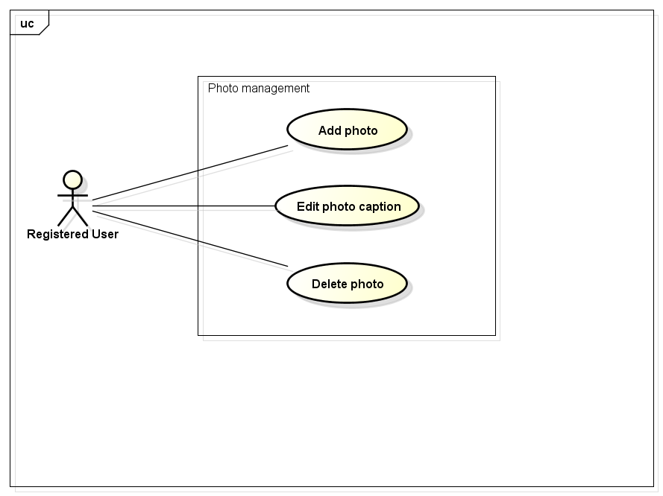

## *User-case Specification*

### Add Photo

|  |  |  |  |  |
| --- | --- | --- | --- | --- |
| **Use Case ID** | | UC014 | **Version** | 1.1 |
| **Use Case Name** | | Add photo | | |
| **Created by:** | | HieuTM | **Date Created:** | 28/05/2015 |
| **Primary Actor** | | Registered user | **Secondary Actor** |  |
| **Description:** | | This function allows user to share information, knowledge, experience via picture and captions | | |
| **Preconditions:** | | 1. FAP website is available 2. User browsed FAP website 3. User logged in to system | | |
| **Trigger:** | | User wants to share information | | |
| **Post conditions:** | | 1. Post is updated to FAP website. 2. Post is updated to User Detail. 3. Post is updated to Database. | | |
| **Normal Flow** | | | | |
| **Step** | **Actor** | **Action** | | |
|  | User | Click Create Post. | | |
|  | FAP | Redirects user to Add Post Page which contain a create form. | | |
|  | User | Click Add Photo. | | |
|  | User | Redirects user to Add Photo Page which contain an add photo form. | | |
|  | User | Click Browse to choose photo. | | |
|  | FAP | Display photo and Caption field | | |
|  | User | Enters information in fields. | | |
|  | User | User click Create or press Enter. | | |
|  | FAP | Create a post | | |
|  | FAP | Updates to user’s timeline | | |
|  | FAP | Updates to News feed of user’s friends | | |
|  | FAP | Displays message “Post is created” | | |
|  | FAP | Redirects user to Post Page which contain created post. | | |
| **Alternative Flows** | | | | |
| **AT1** | At step 8, user click Cancel | | | |
| **Step** | **Actor** | **Action** | | |
| 8.1 | FAP | Redirects user to previous page. | | |
|  | | | | |
| **Exceptions:** | | | | |
| **EC1** | The connection is terminated | | | |
| **Step** | **Actor** | **Action** | | |
| 1 | FAP | All fields are cleared and FAP return to the wait state. | | |
|  | | | | |
| **EC2** | At step 8, required fields are not entered | | | |
| **Step** | **Actor** | **Action** | | |
| 8.1 | FAP | Display Add Post page with message “Required fields are not entered” | | |
| 8.2 | FAP | Mark error fields | | |
|  | | | | |
| **EC3** | At step 8, fields are entered with wrong type of data | | | |
| **Step** | **Actor** | **Action** | | |
| 8.1 | FAP | Display Add Post page with message “Wrong type of data” | | |
| 8.2 | FAP | Mark error fields | | |
|  | | | | |
| **Priority** | | High | | |
| **Frequency of Use:** | | High | | |
| **Business Rules:** | | N/A | | |
| **Other Information:** | | N/A | | |

### Edit Photo Caption

|  |  |  |  |  |
| --- | --- | --- | --- | --- |
| **Use Case ID** | | UC015 | **Version** | 1.1 |
| **Use Case Name** | | Edit photo caption | | |
| **Created by:** | | HieuTM | **Date Created:** | 28/05/2015 |
| **Primary Actor** | | Registered user | **Secondary Actor** | None |
| **Description:** | | This function allows user to edit what they posted | | |
| **Preconditions:** | | 1. FAP website is available 2. User browsed FAP website 3. User logged in to system 4. User are viewing their own post | | |
| **Trigger:** | | User wants to edit information of their own posts | | |
| **Post conditions:** | | 1. Post is updated to FAP website. 2. Post is updated to User Detail. 3. Post is updated to Database. | | |
| **Normal Flow** | | | | |
| **Step** | **Actor** | **Action** | | |
|  | User | Click Edit | | |
|  | FAP | Redirects user to Edit Post Page which contain a create form with information is filled. | | |
|  | User | Edits information in fields. | | |
|  | User | Click Update or press Enter. | | |
|  | FAP | Edit this post | | |
|  | FAP | Displays message “Post is edited” | | |
|  | FAP | Redirects user to Post Page which contain edited post. | | |
| **Alternative Flows** | | | | |
| **AT1** | At step 4, user click Cancel | | | |
| **Step** | **Actor** | **Action** | | |
| 4.1 | FAP | FAP redirects user to previous page. | | |
|  | | | | |
| **Exceptions:** | | | | |
| **EC1** | The connection is terminated | | | |
| **Step** | **Actor** | **Action** | | |
| 1 | FAP | All fields are cleared and FAP return to the wait state. | | |
|  | | | | |
| **EC2** | At step 4, required fields are not entered | | | |
| **Step** | **Actor** | **Action** | | |
| 4.1 | FAP | Display Add Post page with message “Required fields are not entered” | | |
| 4.2 | FAP | Mark error fields | | |
|  | | | | |
| **EC3** | At step 4, fields are entered with wrong type of data | | | |
| **Step** | **Actor** | **Action** | | |
| 4.1 | FAP | Display Add Post page with message “Wrong type of data” | | |
| 4.2 | FAP | Mark error fields | | |
|  | | | | |
| **Priority** | | Normal | | |
| **Frequency of Use:** | | Normal | | |
| **Business Rules:** | | N/A | | |
| **Other Information:** | | N/A | | |

### Delete Photo

|  |  |  |  |  |
| --- | --- | --- | --- | --- |
| **Use Case ID** | | UC016 | **Version** | 1.1 |
| **Use Case Name** | | Delete photo | | |
| **Created by:** | | HieuTM | **Date Created:** | 28/05/2015 |
| **Primary Actor** | | Registered user | **Secondary Actor** |  |
| **Description:** | | This function allows user to delete what they posted | | |
| **Preconditions:** | | 1. FAP website is available 2. User browsed FAP website 3. User logged in to system 4. User are viewing their own post | | |
| **Trigger:** | | User wants to delete information of their own posts | | |
| **Post conditions:** | | 1. Post is deleted in user’s Timeline. 2. Post status is updated to Database. | | |
| **Normal Flow** | | | | |
| **Step** | **Actor** | **Action** | | |
| 1 | User | Click Delete | | |
| 2 | FAP | Display confirm popup “Delete this post?” | | |
| 3 | User | Click OK | | |
| 4 | FAP | Delete this post | | |
| 5 | FAP | Redirects user to Homepage | | |
| **Alternative Flows** | | | | |
| **AT1** | At step 3, user click Cancel | | | |
| **Step** | **Actor** | **Action** | | |
| 3.1 | FAP | Closes confirm popup | | |
|  | | | | |
| **Exceptions:** | | | | |
| **EC1** | The connection is terminated | | | |
| **Step** | **Actor** | **Action** | | |
| 1 | FAP | All fields are cleared and FAP return to the wait state. | | |
|  | | | | |
| **Priority** | | Normal | | |
| **Frequency of Use:** | | Low | | |
| **Business Rules:** | | N/A | | |
| **Other Information:** | | N/A | | |

## Video management

## *Use-case Diagram*

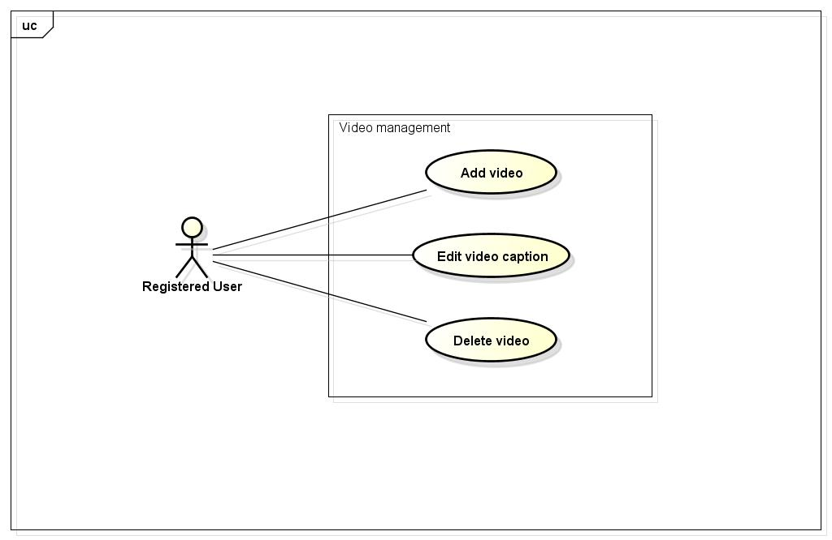

## *User-case Specification*

### Add Video

|  |  |  |  |  |
| --- | --- | --- | --- | --- |
| **Use Case ID** | | UC017 | **Version** | 1.1 |
| **Use Case Name** | | Add video | | |
| **Created by:** | | HieuTM | **Date Created:** | 28/05/2015 |
| **Primary Actor** | | Registered user | **Secondary Actor** |  |
| **Description:** | | This function allows user to share information, knowledge, experience via picture and captions | | |
| **Preconditions:** | | 1. FAP website is available 2. User browsed FAP website 3. User logged in to system | | |
| **Trigger:** | | User wants to share information | | |
| **Post conditions:** | | 1. Post is updated to FAP website. 2. Post is updated to User Detail. 3. Post is updated to Database. | | |
| **Normal Flow** | | | | |
| **Step** | **Actor** | **Action** | | |
|  | User | Click Create Post. | | |
|  | FAP | Redirects user to Add Post Page which contain a create form. | | |
|  | User | Click Add Video. | | |
|  | User | Redirects user to Add Video Page which contain an Add video form. | | |
|  | User | Click Browse to choose video. | | |
|  | FAP | Display video and Caption field | | |
|  | User | Enters information in fields. | | |
|  | User | User click Create or press Enter. | | |
|  | FAP | Create a post | | |
|  | FAP | Updates to user’s timeline | | |
|  | FAP | Updates to News feed of user’s friends | | |
|  | FAP | Displays message “Post is created” | | |
|  | FAP | Redirects user to Post Page which contain created post. | | |
| **Alternative Flows** | | | | |
| **AT1** | At step 8, user click Cancel | | | |
| **Step** | **Actor** | **Action** | | |
| 8.1 | FAP | Redirects user to previous page. | | |
|  | | | | |
| **Exceptions:** | | | | |
| **EC1** | The connection is terminated | | | |
| **Step** | **Actor** | **Action** | | |
| 1 | FAP | All fields are cleared and FAP return to the wait state. | | |
|  | | | | |
| **EC2** | At step 8, required fields are not entered | | | |
| **Step** | **Actor** | **Action** | | |
| 8.1 | FAP | Display Add Post page with message “Required fields are not entered” | | |
| 8.2 | FAP | Mark error fields | | |
|  | | | | |
| **EC3** | At step 8, fields are entered with wrong type of data | | | |
| **Step** | **Actor** | **Action** | | |
| 8.1 | FAP | Display Add Post page with message “Wrong type of data” | | |
| 8.2 | FAP | Mark error fields | | |
|  | | | | |
| **Priority** | | High | | |
| **Frequency of Use:** | | High | | |
| **Business Rules:** | | N/A | | |
| **Other Information:** | | N/A | | |

### Edit Video Caption

|  |  |  |  |  |
| --- | --- | --- | --- | --- |
| **Use Case ID** | | UC018 | **Version** | 1.1 |
| **Use Case Name** | | Edit video caption | | |
| **Created by:** | | HieuTM | **Date Created:** | 28/05/2015 |
| **Primary Actor** | | Registered user | **Secondary Actor** | None |
| **Description:** | | This function allows user to edit what they posted | | |
| **Preconditions:** | | 1. FAP website is available 2. User browsed FAP website 3. User logged in to system 4. User are viewing their own post | | |
| **Trigger:** | | User wants to edit information of their own posts | | |
| **Post conditions:** | | 1. Post is updated to FAP website. 2. Post is updated to User Detail. 3. Post is updated to Database. | | |
| **Normal Flow** | | | | |
| **Step** | **Actor** | **Action** | | |
|  | User | Click Edit | | |
|  | FAP | Redirects user to Edit Post Page which contain a create form with information is filled. | | |
|  | User | Edits information in fields. | | |
|  | User | Click Update or press Enter. | | |
|  | FAP | Edit this post | | |
|  | FAP | Displays message “Post is edited” | | |
|  | FAP | Redirects user to Post Page which contain edited post. | | |
| **Alternative Flows** | | | | |
| **AT1** | At step 4, user click Cancel | | | |
| **Step** | **Actor** | **Action** | | |
| 4.1 | FAP | FAP redirects user to previous page. | | |
|  | | | | |
| **Exceptions:** | | | | |
| **EC1** | The connection is terminated | | | |
| **Step** | **Actor** | **Action** | | |
| 1 | FAP | All fields are cleared and FAP return to the wait state. | | |
|  | | | | |
| **EC2** | At step 4, required fields are not entered | | | |
| **Step** | **Actor** | **Action** | | |
| 4.1 | FAP | Display Add Post page with message “Required fields are not entered” | | |
| 4.2 | FAP | Mark error fields | | |
|  | | | | |
| **EC3** | At step 4, fields are entered with wrong type of data | | | |
| **Step** | **Actor** | **Action** | | |
| 4.1 | FAP | Display Add Post page with message “Wrong type of data” | | |
| 4.2 | FAP | Mark error fields | | |
|  | | | | |
| **Priority** | | Normal | | |
| **Frequency of Use:** | | Normal | | |
| **Business Rules:** | | N/A | | |
| **Other Information:** | | N/A | | |

### Delete Video

|  |  |  |  |  |
| --- | --- | --- | --- | --- |
| **Use Case ID** | | UC019 | **Version** | 1.1 |
| **Use Case Name** | | Delete video | | |
| **Created by:** | | HieuTM | **Date Created:** | 28/05/2015 |
| **Primary Actor** | | Registered user | **Secondary Actor** |  |
| **Description:** | | This function allows user to delete what they posted | | |
| **Preconditions:** | | 1. FAP website is available 2. User browsed FAP website 3. User logged in to system 4. User are viewing their own post | | |
| **Trigger:** | | User wants to delete information of their own posts | | |
| **Post conditions:** | | 1. Post is deleted in user’s Timeline. 2. Post status is updated to Database. | | |
| **Normal Flow** | | | | |
| **Step** | **Actor** | **Action** | | |
| 1 | User | Click Delete | | |
| 2 | FAP | Display confirm popup “Delete this post?” | | |
| 3 | User | Click OK | | |
| 4 | FAP | Delete this post | | |
| 5 | FAP | Redirects user to Homepage | | |
| **Alternative Flows** | | | | |
| **AT1** | At step 3, user click Cancel | | | |
| **Step** | **Actor** | **Action** | | |
| 3.1 | FAP | Closes confirm popup | | |
|  | | | | |
| **Exceptions:** | | | | |
| **EC1** | The connection is terminated | | | |
| **Step** | **Actor** | **Action** | | |
| 1 | FAP | All fields are cleared and FAP return to the wait state. | | |
|  | | | | |
| **Priority** | | Normal | | |
| **Frequency of Use:** | | Low | | |
| **Business Rules:** | | N/A | | |
| **Other Information:** | | N/A | | |

## Share

## *Use-case Diagram*

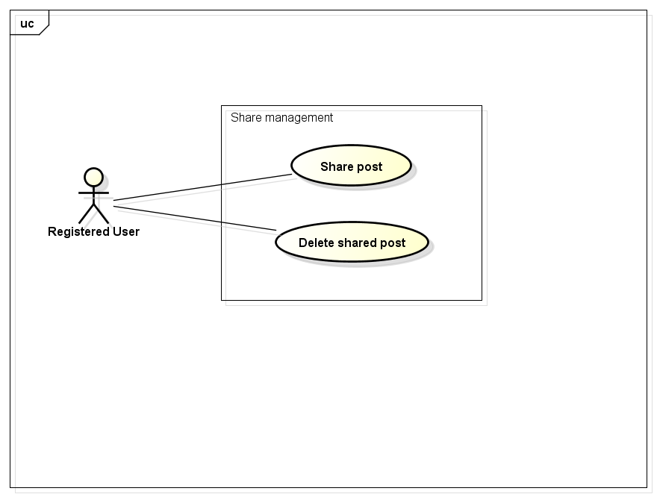

## *User-case Specification*

### Share Post

|  |  |  |  |  |
| --- | --- | --- | --- | --- |
| **Use Case ID** | | UC020 | **Version** | 1.1 |
| **Use Case Name** | | Share post | | |
| **Created by:** | | HieuTM | **Date Created:** | 28/05/2015 |
| **Primary Actor** | | Registered user | **Secondary Actor** | None |
| **Description:** | | This function allows user to share a post, makes it available on timeline | | |
| **Preconditions:** | | 1. FAP website is available 2. User browsed FAP website 3. User logged in to system 4. User are viewing a post | | |
| **Trigger:** | | User wants to share information of others | | |
| **Post conditions:** | | 1. Shared post is updated to user’s timeline 2. Shared post is updated to News feed of user’s friends if available 3. Update share number of shared post | | |
| **Normal Flow** | | | | |
| **Step** | **Actor** | **Action** | | |
| 1 | User | Click Share. | | |
| 2 | FAP | Displays a textbox dialog. | | |
| 3 | User | Enters comment. | | |
| 4 | User | Click Share or press Enter. | | |
| 5 | FAP | Closes dialog.  Updates shared post to user’s timeline.  Redirects user to Post Page. | | |
| **Alternative Flows** | | | | |
| **AT1** | At step 3, user click Cancel | | | |
| **Step** | **Actor** | **Action** | | |
| 3.1 | FAP | Closes confirm popup | | |
|  | | | | |
| **Exceptions:** | | | | |
| **EC1** | The connection is terminated | | | |
| **Step** | **Actor** | **Action** | | |
| 1 | FAP | All fields are cleared and FAP return to the wait state. | | |
|  | | | | |
| **Priority** | | High | | |
| **Frequency of Use:** | | High | | |
| **Business Rules:** | | N/A | | |
| **Other Information:** | | N/A | | |

### Delete Shared Post

|  |  |  |  |  |
| --- | --- | --- | --- | --- |
| **Use Case ID** | | UC021 | **Version** | 1.1 |
| **Use Case Name** | | Delete shared post | | |
| **Created by:** | | HieuTM | **Date Created:** | 28/05/2015 |
| **Primary Actor** | | Registered user | **Secondary Actor** |  |
| **Description:** | | This function allows user to share a post, makes it available on timeline | | |
| **Preconditions:** | | 1. FAP website is available 2. User browsed FAP website 3. User logged in to system 4. User are viewing Timeline | | |
| **Trigger:** | | User wants to share information of others | | |
| **Post conditions:** | | 1. Delete shared post in user’s timeline 2. Update share number of shared post | | |
| **Normal Flow** | | | | |
| **Step** | **Actor** | **Action** | | |
|  | User | Click Delete | | |
|  | FAP | Displays confirm popup “Delete this post?” | | |
|  | User | Click OK | | |
|  | FAP | Closes confirm popup. | | |
|  | FAP | Updates user’s Timeline. | | |
|  | FAP | Updates share number | | |
| **Alternative Flows** | | | | |
| **AT1** | At step 3, user click Cancel | | | |
| **Step** | **Actor** | **Action** | | |
| 3.1 | FAP | Closes confirm popup | | |
|  | | | | |
| **Exceptions:** | | | | |
| **EC1** | The connection is terminated | | | |
| **Step** | **Actor** | **Action** | | |
| 1 | FAP | All fields are cleared and FAP return to the wait state. | | |
|  | | | | |
| **Priority** | | Normal | | |
| **Frequency of Use:** | | Low | | |
| **Business Rules:** | | N/A | | |
| **Other Information:** | | N/A | | |

## Comment

## *Use-case Diagram*

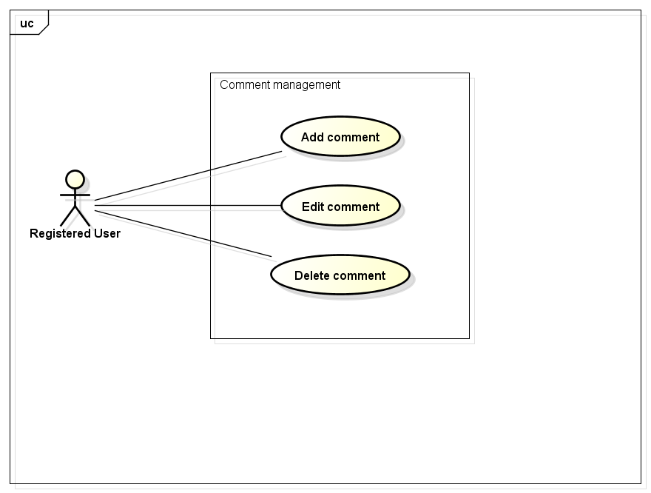

## *User-case Specification*

### Add Comment

|  |  |  |  |  |
| --- | --- | --- | --- | --- |
| **Use Case ID** | | UC022 | **Version** | 1.1 |
| **Use Case Name** | | Add comment | | |
| **Created by:** | | HieuTM | **Date Created:** | 28/05/2015 |
| **Primary Actor** | | Registered user | **Secondary Actor** |  |
| **Description:** | | This function allows user to comment opinion in a post | | |
| **Preconditions:** | | 1. FAP website is available 2. User browsed FAP website 3. User logged in to system 4. User are viewing a post | | |
| **Trigger:** | | User wants to comment in a post | | |
| **Post conditions:** | | Updates post’s comments | | |
| **Normal Flow** | | | | |
| **Step** | **Actor** | **Action** | | |
|  | User | Entered comment into textbox | | |
|  | User | Click Send or press Enter | | |
|  | FAP | Updates post’s comment | | |
|  | FAP | Displays comment | | |
| **Alternative Flows: N/A** | | | | |
| **Exceptions:** | | | | |
| **EC1** | The connection is terminated | | | |
| **Step** | **Actor** | **Action** | | |
| 1 | FAP | All fields are cleared and FAP return to the wait state. | | |
|  | | | | |
| **Priority** | | High | | |
| **Frequency of Use:** | | High | | |
| **Business Rules:** | | N/A | | |
| **Other Information:** | | N/A | | |

### Edit Comment

|  |  |  |  |  |
| --- | --- | --- | --- | --- |
| **Use Case ID** | | UC023 | **Version** | 1.1 |
| **Use Case Name** | | Edit comment | | |
| **Created by:** | | HieuTM | **Date Created:** | 28/05/2015 |
| **Primary Actor** | | Registered user | **Secondary Actor** |  |
| **Description:** | | This function allows user to edit what they commented | | |
| **Preconditions:** | | 1. FAP website is available 2. User browsed FAP website 3. User logged in to system 4. User are viewing a post has their own comments | | |
| **Trigger:** | | User wants to edit comments | | |
| **Post conditions:** | | Updates post’s comments | | |
| **Normal Flow** | | | | |
| **Step** | **Actor** | **Action** | | |
|  | User | Click Edit | | |
|  | User | Displays a textbox | | |
|  | User | Entered comment into textbox | | |
|  | User | Click Edit or press Enter | | |
|  | FAP | Updates comment | | |
|  | FAP | Displays edited comment | | |
| **Alternative Flows: N/A** | | | | |
| **Exceptions:** | | | | |
| **EC1** | The connection is terminated | | | |
| **Step** | **Actor** | **Action** | | |
| 1 | FAP | All fields are cleared and FAP return to the wait state. | | |
|  | | | | |
| **Priority** | | Normal | | |
| **Frequency of Use:** | | Normal | | |
| **Business Rules:** | | N/A | | |
| **Other Information:** | | N/A | | |

### Delete Comment

|  |  |  |  |  |
| --- | --- | --- | --- | --- |
| **Use Case ID** | | UC024 | **Version** | 1.1 |
| **Use Case Name** | | Delete comment | | |
| **Created by:** | | HieuTM | **Date Created:** | 28/05/2015 |
| **Primary Actor** | | Registered user | **Secondary Actor** |  |
| **Description:** | | This function allows user to edit what they commented | | |
| **Preconditions:** | | 1. FAP website is available 2. User browsed FAP website 3. User logged in to system 4. User are viewing a post has their own comments | | |
| **Trigger:** | | User wants to edit comments | | |
| **Post conditions:** | | 1. Post’s comment is deleted | | |
| **Normal Flow** | | | | |
| **Step** | **Actor** | **Action** | | |
|  | User | Click Delete | | |
|  | User | Displays confirm popup “Delete this comment?” | | |
|  | User | Click OK | | |
|  | User | Deletes comment | | |
|  | FAP | Display post without deleted comment | | |
| **Alternative Flows: N/A** | | | | |
| **Exceptions:** | | | | |
| **EC1** | The connection is terminated | | | |
| **Step** | **Actor** | **Action** | | |
| 1 | FAP | All fields are cleared and FAP return to the wait state. | | |
|  | | | | |
| **Priority** | | Normal | | |
| **Frequency of Use:** | | Low | | |
| **Business Rules:** | | N/A | | |
| **Other Information:** | | N/A | | |

## Like

## *Use-case Diagram*

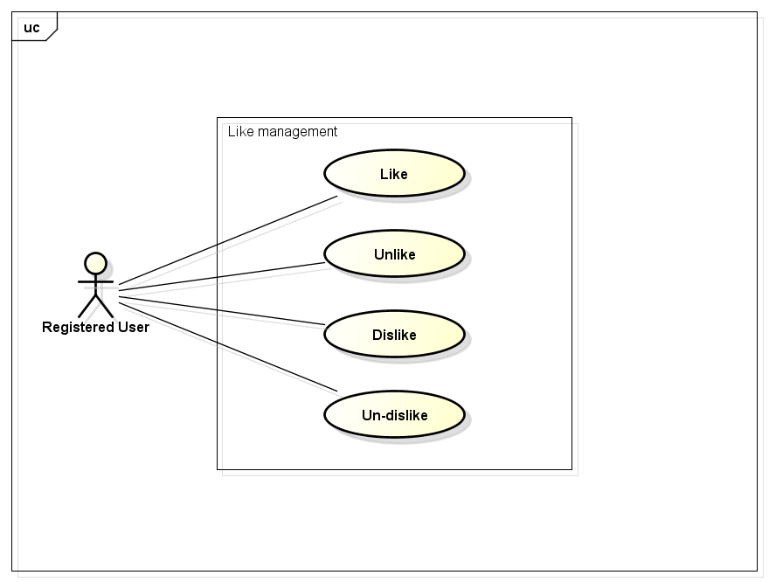

## *User-case Specification*

### Like

|  |  |  |  |  |
| --- | --- | --- | --- | --- |
| **Use Case ID** | | UC025 | **Version** | 1.1 |
| **Use Case Name** | | Like | | |
| **Created by:** | | HieuTM | **Date Created:** | 28/05/2015 |
| **Primary Actor** | | Registered user | **Secondary Actor** |  |
| **Description:** | | This function allows user to rate a post or a comment | | |
| **Preconditions:** | | 1. FAP website is available 2. User browsed FAP website 3. User logged in to system 4. User are viewing a post or a comment | | |
| **Trigger:** | | User likes a comment and rates as Liked | | |
| **Post conditions:** | | 1. Liked post is updated to user’s timeline 2. Liked post is updated to News feed of user’s friends if available 3. Update like number of liked post or comment | | |
| **Normal Flow** | | | | |
| **Step** | **Actor** | **Action** | | |
|  | User | Click Like | | |
|  | FAP | Updates liked post to user’s timeline | | |
|  | FAP | Updates liked post to News feed of user’s friends | | |
|  | FAP | Update like number of liked post | | |
|  | FAP | Displays post or comment as Liked | | |
| **Alternative Flows: N/A** | | | | |
| **Exceptions:** | | | | |
| **EC1** | The connection is terminated | | | |
| **Step** | **Actor** | **Action** | | |
| 1 | FAP | Return to the wait state. | | |
|  | | | | |
| **Priority** | | High | | |
| **Frequency of Use:** | | High | | |
| **Business Rules:** | | N/A | | |
| **Other Information:** | | N/A | | |

### Unlike

|  |  |  |  |  |
| --- | --- | --- | --- | --- |
| **Use Case ID** | | UC026 | **Version** | 1.1 |
| **Use Case Name** | | Unlike | | |
| **Created by:** | | HieuTM | **Date Created:** | 28/05/2015 |
| **Primary Actor** | | Registered user | **Secondary Actor** |  |
| **Description:** | | This function allows user to remove Like status of a post or comment | | |
| **Preconditions:** | | 1. FAP website is available 2. User browsed FAP website 3. User logged in to system 4. User are viewing a post or a comment they liked | | |
| **Trigger:** | | User wants to remove their Liked rate | | |
| **Post conditions:** | | 1. Unlike post is updated to user’s timeline 2. Update like number of liked post or comment | | |
| **Normal Flow** | | | | |
| **Step** | **Actor** | **Action** | | |
|  | User | Click Unlike | | |
|  | FAP | Updates unlike post to user’s timeline | | |
|  | FAP | Update like number of liked post | | |
|  | FAP | Displays post or comment as normal | | |
| **Alternative Flows: N/A** | | | | |
| **Exceptions:** | | | | |
| **EC1** | The connection is terminated | | | |
| **Step** | **Actor** | **Action** | | |
| 1 | FAP | Return to the wait state. | | |
|  | | | | |
| **Priority** | | Normal | | |
| **Frequency of Use:** | | Normal | | |
| **Business Rules:** | | N/A | | |
| **Other Information:** | | N/A | | |

### Dislike

|  |  |  |  |  |
| --- | --- | --- | --- | --- |
| **Use Case ID** | | UC027 | **Version** | 1.1 |
| **Use Case Name** | | Dislike | | |
| **Created by:** | | HieuTM | **Date Created:** | 28/05/2015 |
| **Primary Actor** | | Registered user | **Secondary Actor** |  |
| **Description:** | | This function allows user to rate a post or a comment | | |
| **Preconditions:** | | 1. FAP website is available 2. User browsed FAP website 3. User logged in to system 4. User are viewing a post or a comment | | |
| **Trigger:** | | User does not like a comment and rates as Dislike | | |
| **Post conditions:** | | 1. Dislike post is updated to user’s timeline 2. Dislike post is updated to News feed of user’s friends if available 3. Update dislike number of dislike post or comment | | |
| **Normal Flow** | | | | |
| **Step** | **Actor** | **Action** | | |
|  | User | Click Dislike | | |
|  | FAP | Updates dislike post to user’s timeline | | |
|  | FAP | Updates dislike post to News feed of user’s friends | | |
|  | FAP | Update dislike number of dislike post | | |
|  | FAP | Display post or comment as Disliked | | |
| **Alternative Flows: N/A** | | | | |
| **Exceptions:** | | | | |
| **EC1** | The connection is terminated | | | |
| **Step** | **Actor** | **Action** | | |
| 1 | FAP | All fields are cleared and FAP return to the wait state. | | |
|  | | | | |
| **Priority** | | High | | |
| **Frequency of Use:** | | High | | |
| **Business Rules:** | | N/A | | |
| **Other Information:** | | N/A | | |

### Un-dislike

|  |  |  |  |  |
| --- | --- | --- | --- | --- |
| **Use Case ID** | | UC028 | **Version** | 1.1 |
| **Use Case Name** | | Un-dislike | | |
| **Created by:** | | HieuTM | **Date Created:** | 28/05/2015 |
| **Primary Actor** | | Registered user | **Secondary Actor** |  |
| **Description:** | | This function allows user to remove Like status of a post or comment | | |
| **Preconditions:** | | 1. FAP website is available 2. User browsed FAP website 3. User logged in to system 4. User are viewing a post or a comment they liked | | |
| **Trigger:** | | User wants to remove their Liked rate | | |
| **Post conditions:** | | 1. Un-dislike post or comment is updated to user’s timeline 2. Update dislike number of un-dislike post or comment | | |
| **Normal Flow** | | | | |
| **Step** | **Actor** | **Action** | | |
|  | User | Click Unlike | | |
|  | FAP | Updates unlike post to user’s timeline | | |
|  | FAP | Update like number of liked post | | |
|  | FAP | Displays post or comment as normal | | |
| **Alternative Flows: N/A** | | | | |
| **Exceptions:** | | | | |
| **EC1** | The connection is terminated | | | |
| **Step** | **Actor** | **Action** | | |
| 1 | FAP | All fields are cleared and FAP return to the wait state. | | |
|  | | | | |
| **Priority** | | Normal | | |
| **Frequency of Use:** | | Normal | | |
| **Business Rules:** | | N/A | | |
| **Other Information:** | | N/A | | |

## Report

## *Use-case Diagram*

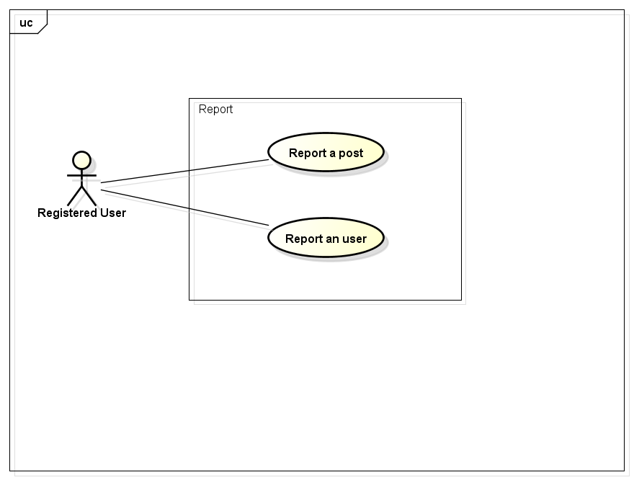

## *User-case Specification*

### Report a post

|  |  |  |  |  |
| --- | --- | --- | --- | --- |
| **Use Case ID** | | UC029 | **Version** | 1.1 |
| **Use Case Name** | | Report a post | | |
| **Created by:** | | HieuTM | **Date Created:** | 28/05/2015 |
| **Primary Actor** | | Registered user | **Secondary Actor** |  |
| **Description:** | | This function allows user to report a post or comment violated rules | | |
| **Preconditions:** | | 1. FAP website is available 2. User browsed FAP website 3. User logged in to system 4. User are viewing a post or a comment | | |
| **Trigger:** | | User wants to report a post violated rules | | |
| **Post conditions:** | | 1. Report is sent to admin | | |
| **Normal Flow** | | | | |
| **Step** | **Actor** | **Action** | | |
|  | User | Click Report. | | |
|  | FAP | Displays popup. | | |
|  | User | Choose common reason. | | |
|  | User | Click Report or press Enter. | | |
|  | FAP | Closes dialog. | | |
|  | FAP | Sent report to admin | | |
|  | FAP | Display message “This post has been reported” | | |
| **Alternative Flows** | | | | |
| **AT1** | At step 3, user choose Other: | | | |
| **Step** | **Actor** | **Action** | | |
| 3.1 | FAP | Displays a textbox dialog. | | |
| 3.2 | User | Enters reason into textbox. | | |
| 3.3 | User | Click Report or press Enter. | | |
| 3.4 | FAP | Closes dialog. | | |
| 3.5 | FAP | Sent report to admin | | |
| 3.6 | FAP | Display message “This post has been reported” | | |
|  | | | | |
| **AT2** | At step 4, user choose Cancel: | | | |
| **Step** | **Actor** | **Action** | | |
| 4.1 | FAP | Closes popup. | | |
| **Exceptions:** | | | | |
| **EC1** | The connection is terminated | | | |
| **Step** | **Actor** | **Action** | | |
| 1 | FAP | All fields are cleared and FAP return to the wait state. | | |
|  | | | | |
| **Priority** | | Normal | | |
| **Frequency of Use:** | | Normal | | |
| **Business Rules:** | | N/A | | |
| **Other Information:** | | N/A | | |

### Report a user

|  |  |  |  |  |
| --- | --- | --- | --- | --- |
| **Use Case ID** | | UC030 | **Version** | 1.1 |
| **Use Case Name** | | Report an user | | |
| **Created by:** | | HieuTM | **Date Created:** | 28/05/2015 |
| **Primary Actor** | | Registered user | **Secondary Actor** |  |
| **Description:** | | This function allows user to report an user who violated rules | | |
| **Preconditions:** | | 1. FAP website is available 2. User browsed FAP website 3. User logged in to system 4. User are viewing a post or a comment | | |
| **Trigger:** | | User wants to report an user who violated rules | | |
| **Post conditions:** | | 1. Report is sent to admin | | |
| **Normal Flow** | | | | |
| **Step** | **Actor** | **Action** | | |
|  | User | Click a User name. | | |
|  | FAP | Displays a menu. | | |
|  | User | Click Report. | | |
|  | FAP | Displays popup. | | |
|  | User | Choose common reason. | | |
|  | User | Click Report or press Enter. | | |
|  | FAP | Closes dialog. | | |
|  | FAP | Sent report to admin | | |
|  | FAP | Display message “This user has been reported” | | |
| **Alternative Flows** | | | | |
| **AT2** | At step 3, user choose Other: | | | |
| **Step** | **Actor** | **Action** | | |
| 3.1 | FAP | Displays a textbox dialog. | | |
| 3.2 | User | Enters reason into textbox. | | |
| 3.3 | User | Click Report or press Enter. | | |
| 3.4 | FAP | Closes dialog. | | |
| 3.5 | FAP | Sent report to admin | | |
| 3.6 | FAP | Display message “This post has been reported” | | |
|  | | | | |
| **AT3** | At step 4, user choose Cancel: | | | |
| **Step** | **Actor** | **Action** | | |
| 4.1 | FAP | Closes popup. | | |
| **Exceptions:** | | | | |
| **EC1** | The connection is terminated | | | |
| **Step** | **Actor** | **Action** | | |
| 1 | FAP | All fields are cleared and FAP return to the wait state. | | |
|  | | | | |
| **Priority** | | Normal | | |
| **Frequency of Use:** | | Normal | | |
| **Business Rules:** | | N/A | | |
| **Other Information:** | | N/A | | |

## Chat

## *Use-case Diagram*

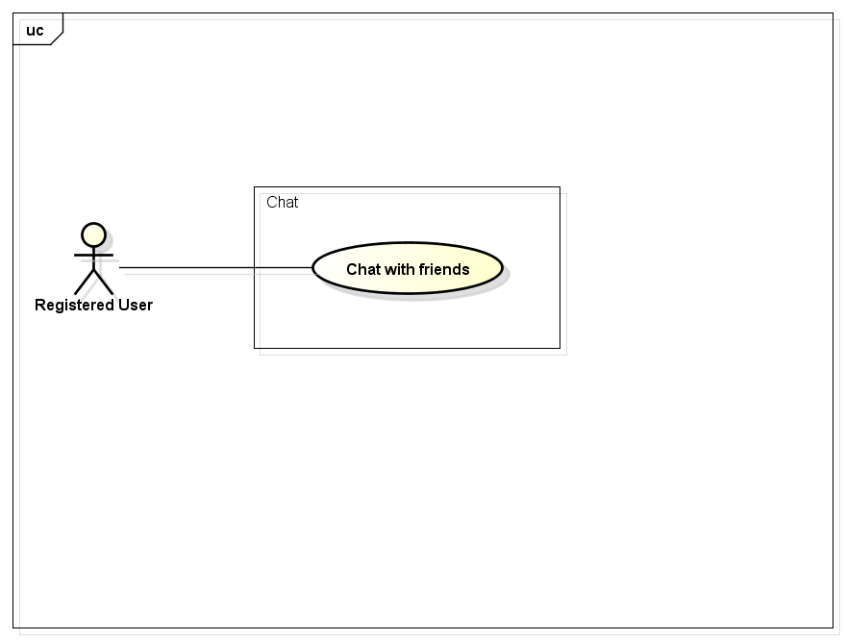

## *User-case Specification*

### Chat with Friends

|  |  |  |  |  |
| --- | --- | --- | --- | --- |
| **Use Case ID** | | UC031 | **Version** | 1.1 |
| **Use Case Name** | | Report a post | | |
| **Created by:** | | HieuTM | **Date Created:** | 28/05/2015 |
| **Primary Actor** | | Registered user | **Secondary Actor** |  |
| **Description:** | | This function allows user to report a post or comment violated rules | | |
| **Preconditions:** | | 1. FAP website is available 2. User browsed FAP website 3. User logged in to system | | |
| **Trigger:** | | User wants to report a post violated rules | | |
| **Post conditions:** | | 1. Chat contents is sent | | |
| **Normal Flow** | | | | |
| **Step** | **Actor** | **Action** | | |
|  | User | Click Friend List. | | |
|  | FAP | Displays friend list. | | |
|  | User | Click friend’s name. | | |
|  | FAP | Displays chat box. | | |
|  | User | Enters message to chat box. | | |
|  | User | Click Send or press Enter. | | |
|  | FAP | Sends message to friend. | | |
|  | FAP | Displays message on chat box. | | |
| **Alternative Flows: N/A** | | | | |
| **Exceptions:** | | | | |
| **EC1** | The connection is terminated | | | |
| **Step** | **Actor** | **Action** | | |
| 1 | FAP | All fields are cleared and FAP return to the wait state. | | |
|  | | | | |
| **Priority** | | High | | |
| **Frequency of Use:** | | High | | |
| **Business Rules:** | | N/A | | |
| **Other Information:** | | N/A | | |

## Friend management

## *Use-case Diagram*

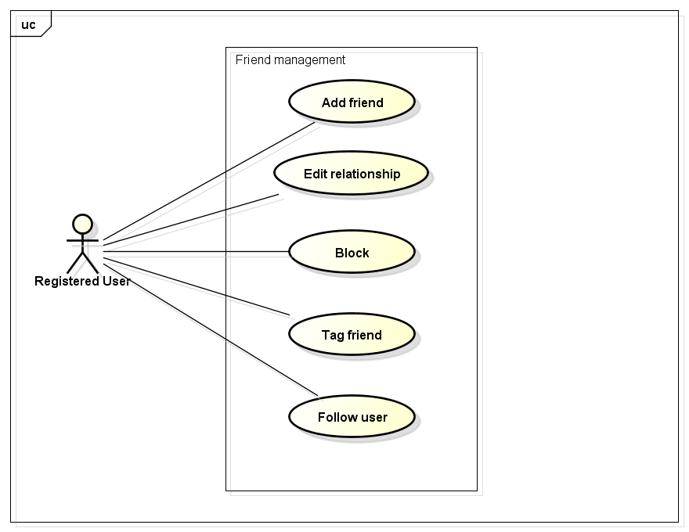

## *User-case Specification*

### Add Friend

|  |  |  |  |  |
| --- | --- | --- | --- | --- |
| **Use Case ID** | | UC032 | **Version** | 1.1 |
| **Use Case Name** | | Add friend | | |
| **Created by:** | | HieuTM | **Date Created:** | 28/05/2015 |
| **Primary Actor** | | Registered user | **Secondary Actor** |  |
| **Description:** | | This function allows user to add others to friend list to chat or see their activities and updates | | |
| **Preconditions:** | | 1. FAP website is available 2. User browsed FAP website 3. User logged in to system 4. User are viewing a post or a comment | | |
| **Trigger:** | | User wants to add others to friend list | | |
| **Post conditions:** | | 1. Friend request is sent | | |
| **Normal Flow** | | | | |
| **Step** | **Actor** | **Action** | | |
|  | User | Click a User name. | | |
|  | FAP | Displays a menu. | | |
|  | User | Click Add Friend. | | |
|  | FAP | Displays message popup. | | |
|  | User | Enters message into textbox. | | |
|  | User | Click Add or press Enter. | | |
|  | FAP | Closes popup. | | |
|  | FAP | Sends request to user | | |
|  | FAP | Display message “Friend request has been sent” | | |
| **Alternative Flows** | | | | |
| **AT1** | At step 6, user choose Cancel: | | | |
| **Step** | **Actor** | **Action** | | |
| 6.1 | FAP | Closes popup. | | |
|  | | | | |
| **Exceptions:** | | | | |
| **EC1** | The connection is terminated | | | |
| **Step** | **Actor** | **Action** | | |
| 1 | FAP | All fields are cleared and FAP return to the wait state. | | |
|  | | | | |
| **Priority** | | High | | |
| **Frequency of Use:** | | High | | |
| **Business Rules:** | | N/A | | |
| **Other Information:** | | N/A | | |

### Edit Relationship

|  |  |  |  |  |
| --- | --- | --- | --- | --- |
| **Use Case ID** | | UC033 | **Version** | 1.1 |
| **Use Case Name** | | Edit relationship | | |
| **Created by:** | | HieuTM | **Date Created:** | 28/05/2015 |
| **Primary Actor** | | Registered user | **Secondary Actor** |  |
| **Description:** | | This function allows user to change default relationship or makes self-define relationship with friends | | |
| **Preconditions:** | | 1. FAP website is available 2. User browsed FAP website 3. User logged in to system 4. User are viewing a post or a comment 5. User can change relationship with others are in friend list only | | |
| **Trigger:** | | User wants to change relationship | | |
| **Post conditions:** | | 1. Relationship change request is sent | | |
| **Normal Flow** | | | | |
| **Step** | **Actor** | **Action** | | |
|  | User | Click a User name. | | |
|  | FAP | Displays a menu. | | |
|  | User | Click Relationship. | | |
|  | FAP | Displays popup. | | |
|  | User | Choose relationship. | | |
|  | User | Click Change or press Enter. | | |
|  | FAP | Closes dialog. | | |
|  | FAP | Sends change relationship request | | |
|  | FAP | Display message “Request has been sent” | | |
| **Alternative Flows** | | | | |
| **AT1** | At step 5, user choose Other: | | | |
| **Step** | **Actor** | **Action** | | |
| 5.1 | FAP | Displays a textbox dialog. | | |
| 5.2 | User | Enters relationship into textbox. | | |
| 5.3 | User | Click Change or press Enter. | | |
| 5.4 | FAP | Closes dialog. | | |
| 5.5 | FAP | Sends change relationship request | | |
| 5.6 | FAP | Display message “Request has been sent” | | |
|  | | | | |
| **AT3** | At step 6, user choose Cancel: | | | |
| **Step** | **Actor** | **Action** | | |
| 6.1 | FAP | Closes popup. | | |
|  | | | | |
| **Exceptions:** | | | | |
| **EC1** | The connection is terminated | | | |
| **Step** | **Actor** | **Action** | | |
| 1 | FAP | All fields are cleared and FAP return to the wait state. | | |
|  | | | | |
| **Priority** | | Normal | | |
| **Frequency of Use:** | | Normal | | |
| **Business Rules:** | | N/A | | |
| **Other Information:** | | N/A | | |

### Unfriend

|  |  |  |  |  |
| --- | --- | --- | --- | --- |
| **Use Case ID** | | UC034 | **Version** | 1.1 |
| **Use Case Name** | | Unfriend | | |
| **Created by:** | | HieuTM | **Date Created:** | 28/05/2015 |
| **Primary Actor** | | Registered user | **Secondary Actor** |  |
| **Description:** | | This function allows user to remove others from friend list | | |
| **Preconditions:** | | 1. FAP website is available 2. User browsed FAP website 3. User logged in to system 4. User are viewing a post or a comment | | |
| **Trigger:** | | User wants to add others to friend list | | |
| **Post conditions:** | | 1. Friend is removed from list | | |
| **Normal Flow** | | | | |
| **Step** | **Actor** | **Action** | | |
|  | User | Click a User name. | | |
|  | FAP | Displays a menu. | | |
|  | User | Click Unfriend. | | |
|  | FAP | Displays confirm popup “Unfriend this user?” | | |
|  | User | Click OK. | | |
|  | FAP | Closes popup. | | |
|  | FAP | Remove friend from list | | |
| **Alternative Flows** | | | | |
| **AT1** | At step 5, user choose Cancel: | | | |
| **Step** | **Actor** | **Action** | | |
| 5.1 | FAP | Closes popup. | | |
|  | | | | |
| **Exceptions:** | | | | |
| **EC1** | The connection is terminated | | | |
| **Step** | **Actor** | **Action** | | |
| 1 | FAP | All fields are cleared and FAP return to the wait state. | | |
|  | | | | |
| **Priority** | | High | | |
| **Frequency of Use:** | | High | | |
| **Business Rules:** | | N/A | | |
| **Other Information:** | | N/A | | |

### Block

|  |  |  |  |  |
| --- | --- | --- | --- | --- |
| **Use Case ID** | | UC035 | **Version** | 1.1 |
| **Use Case Name** | | Block | | |
| **Created by:** | | HieuTM | **Date Created:** | 28/05/2015 |
| **Primary Actor** | | Registered user | **Secondary Actor** |  |
| **Description:** | | This function allows user to block a user to not receive notifications or to not view that user posts and comments. | | |
| **Preconditions:** | | 1. FAP website is available 2. User browsed FAP website 3. User logged in to system 4. User are viewing a post or a comment | | |
| **Trigger:** | | User wants to block an user | | |
| **Post conditions:** | | 1. Blocked user’s posts is not displayed 2. Blocked user’s comments is not displayed | | |
| **Normal Flow** | | | | |
| **Step** | **Actor** | **Action** | | |
|  | User | Click a User name. | | |
|  | FAP | Displays a menu. | | |
|  | User | Click Block. | | |
|  | FAP | Displays confirm popup “Block this user?” | | |
|  | User | Click OK. | | |
|  | FAP | Closes dialog. | | |
|  | FAP | Hide all blocked user’s posts and comments | | |
|  | FAP | Display message “This user has been added to your block list” | | |
| **Alternative Flows** | | | | |
| **AT1** | At step 5, user choose Cancel: | | | |
| **Step** | **Actor** | **Action** | | |
| 5.1 | FAP | Closes popup. | | |
|  | | | | |
| **Exceptions:** | | | | |
| **EC1** | The connection is terminated | | | |
| **Step** | **Actor** | **Action** | | |
| 1 | FAP | All fields are cleared and FAP return to the wait state. | | |
|  | | | | |
| **Priority** | | Normal | | |
| **Frequency of Use:** | | Normal | | |
| **Business Rules:** | | N/A | | |
| **Other Information:** | | N/A | | |

### Tag Friend on Post

|  |  |  |  |  |
| --- | --- | --- | --- | --- |
| **Use Case ID** | | UC036 | **Version** | 1.1 |
| **Use Case Name** | | Tag friend on post | | |
| **Created by:** | | HieuTM | **Date Created:** | 28/05/2015 |
| **Primary Actor** | | Registered user | **Secondary Actor** |  |
| **Description:** | | This function allows user to tag friends, let friend receive notification about post or comment they were tagged. | | |
| **Preconditions:** | | 1. FAP website is available 2. User browsed FAP website 3. User logged in to system 4. User are viewing Add Post page or Add Video page | | |
| **Trigger:** | | User wants to send notification to friends | | |
| **Post conditions:** | | Notification is sent to tagged users | | |
| **Normal Flow** | | | | |
| **Step** | **Actor** | **Action** | | |
|  | User | Click Tag | | |
|  | FAP | Type whole or part of friends’ name into textbox. | | |
|  | User | Choose friends in suggest menu | | |
|  | FAP | Enters required fields | | |
|  | User | Click Create. | | |
|  | FAP | Sends notifications to tagged friends. | | |
| **Alternative Flows** | | | | |
| **AT3** | At step 5, user choose Cancel: | | | |
| **Step** | **Actor** | **Action** | | |
| 5.1 | FAP | Redirects user to previous page. | | |
| **Exceptions:** | | | | |
| **EC1** | The connection is terminated | | | |
| **Step** | **Actor** | **Action** | | |
| 1 | FAP | All fields are cleared and FAP return to the wait state. | | |
|  | | | | |
| **EC2** | At step 4, required fields are not entered | | | |
| **Step** | **Actor** | **Action** | | |
| 4.1 | FAP | Display Add Post page with message “Required fields are not entered” | | |
| 4.2 | FAP | Mark error fields | | |
|  | | | | |
| **EC3** | At step 4, fields are entered with wrong type of data | | | |
| **Step** | **Actor** | **Action** | | |
| 4.1 | FAP | Display Add Post page with message “Wrong type of data” | | |
| 4.2 | FAP | Mark error fields | | |
|  | | | | |
| **Priority** | | High | | |
| **Frequency of Use:** | | High | | |
| **Business Rules:** | | N/A | | |
| **Other Information:** | | N/A | | |

### Follow

|  |  |  |  |  |
| --- | --- | --- | --- | --- |
| **Use Case ID** | | UC037 | **Version** | 1.1 |
| **Use Case Name** | | Follow | | |
| **Created by:** | | HieuTM | **Date Created:** | 28/05/2015 |
| **Primary Actor** | | Registered user | **Secondary Actor** |  |
| **Description:** | | This function allows user to know others activity. | | |
| **Preconditions:** | | 1. FAP website is available 2. User browsed FAP website 3. User logged in to system 4. User are viewing a post or a comment | | |
| **Trigger:** | | User wants to know others activity without becoming friend. | | |
| **Post conditions:** | | 1. Followed user is added to Follow list 2. Activities of followed user are updated to News feed | | |
| **Normal Flow** | | | | |
| **Step** | **Actor** | **Action** | | |
|  | User | Click a User name. | | |
|  | FAP | Displays a menu. | | |
|  | User | Click Follow. | | |
|  | FAP | Adds followed user to Follow list | | |
|  | FAP | Updates activities of followed user to News feed automatically | | |
| **Alternative Flows: N/A** | | | | |
| **Exceptions:** | | | | |
| **EC1** | The connection is terminated | | | |
| **Step** | **Actor** | **Action** | | |
| 1 | FAP | All fields are cleared and FAP return to the wait state. | | |
|  | | | | |
| **Priority** | | High | | |
| **Frequency of Use:** | | High | | |
| **Business Rules:** | | N/A | | |
| **Other Information:** | | N/A | | |

## Room

## *Use-case Diagram*

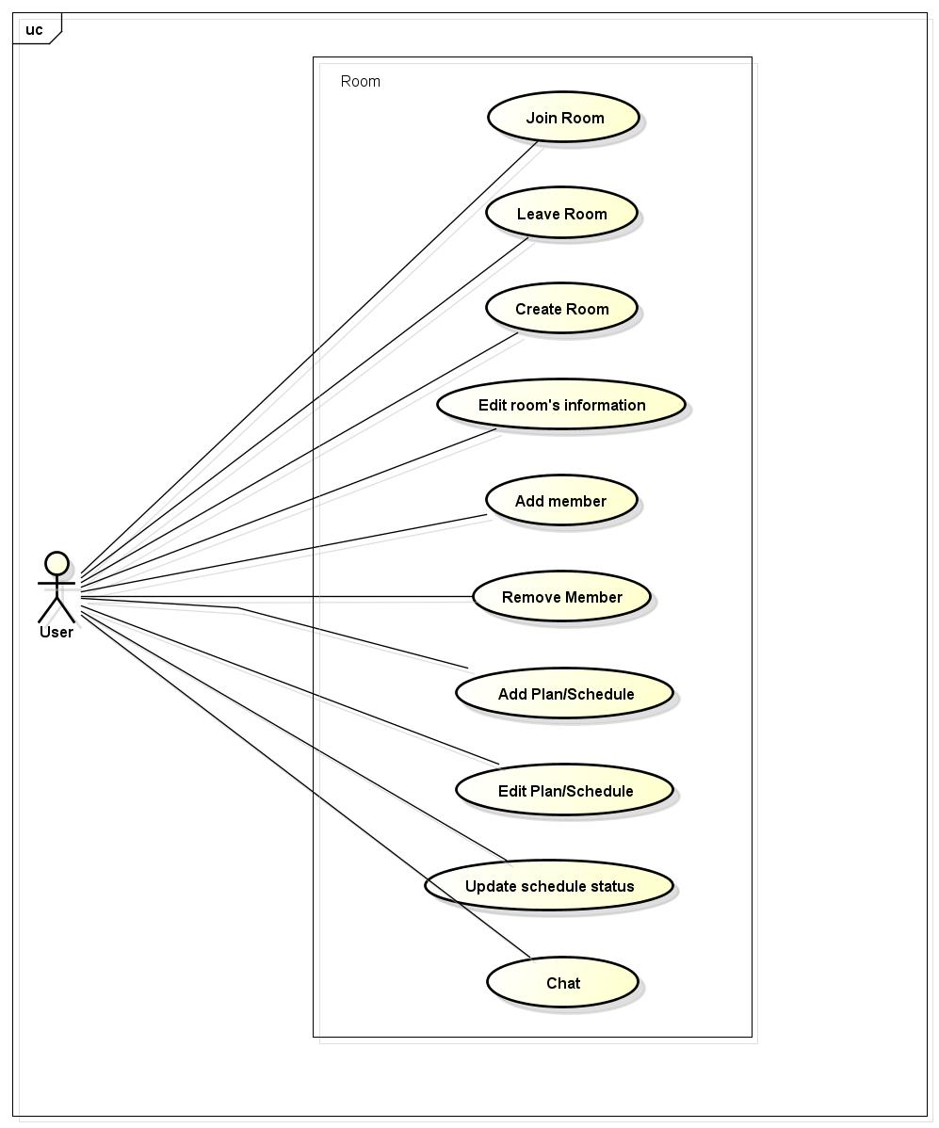

## *User-case Specification*

### Join room

|  |  |  |  |  |
| --- | --- | --- | --- | --- |
| **Use Case ID** | | UC038 | **Version** | 1.0 |
| **Use Case Name** | | Join room | | |
| **Created by:** | | ThuyLM | **Date Created:** | 11/06/2015 |
| **Primary Actor** | | Registered user | **Secondary Actor** | None |
| **Description:** | | This function allows user join an existing room | | |
| **Preconditions:** | | 1. FAP must be connected to the Internet 2. User browsed FAP website 3. User logged in to system 4. Room have been existing | | |
| **Trigger:** | | Application run normally and display any screen of FAP | | |
| **Post conditions:** | | User join a room | | |
| **Normal Flow** | | | | |
| **Step** | **Actor** | **Action** | | |
|  | User | Click on Room in Room list screen/Search Result screen | | |
|  | FAP | Redirect user to Room Details screen | | |
| **Alternative Flows:** | | | | |
| **AT1** | At step 1, if Room is private | | | |
| **Step** | **Actor** | **Action** | | |
| 1.1 | User | Enter Room ID on Search panel | | |
| 1.2 | User | Click Search or press Enter | | |
| 1.3 | FAP | Display Room on Search Result screen | | |
| 1.4 | User | Click on Room thumbnail | | |
| 1.5 | FAP | Redirect user to Room Details screen | | |
|  | | | | |
| **AT2** | If user has been invited by a member of room | | | |
| **Step** | **Actor** | **Action** | | |
| 1.1 | FAP | Display notification to user | | |
| 1.2 | User | Click on invitation | | |
| 1.3 | FAP | Redirect user to Room Details screen | | |
|  | | | | |
| **Exceptions:** | | | | |
| **EC1** | The connection is terminated | | | |
| **Step** | **Actor** | **Action** | | |
| 1 | FAP | All fields are cleared and FAP return to the wait state. | | |
|  | | | | |
| **EC2** | Room ID is not existed | | | |
| **Step** | **Actor** | **Action** | | |
| 1 | FAP | Display Search Result screen with message “Nothing found.” | | |
|  | | | | |
| **Priority** | | High | | |
| **Frequency of Use:** | | High | | |
| **Business Rules:** | |  | | |
| **Other Information:** | | N/A | | |

### Leave room

|  |  |  |  |  |
| --- | --- | --- | --- | --- |
| **Use Case ID** | | UC039 | **Version** | 1.0 |
| **Use Case Name** | | Leave room | | |
| **Created by:** | | ThuyLM | **Date Created:** | 11/06/2015 |
| **Primary Actor** | | Registered user | **Secondary Actor** |  |
| **Description:** | | This function allows users to leave a room that they have join | | |
| **Preconditions:** | | 1. FAP must be connected to the Internet 2. User browsed FAP website 3. User logged in to system 4. User has join a room | | |
| **Trigger:** | | Application run normally and display Room Screen | | |
| **Post conditions:** | | 1. User is no longer on that room 2. Room has been deleted from user’s room list | | |
| **Normal Flow** | | | | |
| **Step** | **Actor** | **Action** | | |
|  | User | Click on Setting button on Room Screen | | |
|  | User | Click “Exit” | | |
|  | FAP | 1. Redirect user to Homepage 2. Delete room name from user’s room list 3. Show message “[Username] has left room” on Room Screen 4. Replace username on schedule/plan by “Left member” | | |
| **Alternative Flows: N/A** | | | | |
| **Exceptions:** | | | | |
| **EC1** | The connection is terminated | | | |
| **Step** | **Actor** | **Action** | | |
| 1 | FAP | FAP return to the wait state, user did not leave the room. | | |
|  | | | | |
| **Priority** | | High | | |
| **Frequency of Use:** | | High | | |
| **Business Rules:** | | N/A | | |
| **Other Information:** | | N/A | | |

### Create room

|  |  |  |  |  |
| --- | --- | --- | --- | --- |
| **Use Case ID** | | UC040 | **Version** | 1.0 |
| **Use Case Name** | | Create room | | |
| **Created by:** | | ThuyLM | **Date Created:** | 11/06/2015 |
| **Primary Actor** | | Registered user | **Secondary Actor** |  |
| **Description:** | | This function allows user to create new room | | |
| **Preconditions:** | | 1. FAP must be connected to the Internet 2. User browsed FAP website 3. User logged in to system | | |
| **Trigger:** | | Application runs normally and display any page of FAP | | |
| **Post conditions:** | | A new room will be created | | |
| **Normal Flow** | | | | |
| **Step** | **Actor** | **Action** | | |
|  | User | Click on (+) float icon on any page of FAP | | |
|  | User | Click “Create Room” button | | |
|  | FAP | Display a window with fields and button:   * Room name * Place + Locate button * Start date * End date * Public/Private state * Add friend button * Create button * Cancel button | | |
|  | User | Fill information of room | | |
|  | User | Click “Create” | | |
|  | FAP | Create room | | |
|  | FAP | Redirect user to their new room | | |
| **Alternative Flows** | | | | |
| **AT1** | At step 5 in the main flows, user left Room name blank | | | |
| **Step** | **Actor** | **Action** | | |
| 5.1 | FAP | Display message: “Your room name cannot be blank” | | |
| 5.2 | FAP | Return to step 4 | | |
|  | | | | |
| **AT2** | At step 3 in the main flow, user clicks on Cancel button | | | |
| **Step** | **Actor** | **Action** | | |
| 5.1 | FAP | Return to previous screen | | |
|  | | | | |
| **Exceptions:** | | | | |
| **EC1** | The connection is terminated | | | |
| **Step** | **Actor** | **Action** | | |
| 1 | FAP | All fields are cleared and FAP return to the wait state. | | |
|  | | | | |
| **Priority** | | High | | |
| **Frequency of Use:** | | High | | |
| **Business Rules:** | |  | | |
| **Other Information:** | | Not required fields will be filled with default value of FAP | | |

### Edit room’s information

|  |  |  |  |  |
| --- | --- | --- | --- | --- |
| **Use Case ID** | | UC04 | **Version** | 1.0 |
| **Use Case Name** | | Edit room’s information | | |
| **Created by:** | | ThuyLM | **Date Created:** | 11/06/2015 |
| **Primary Actor** | | Registered user | **Secondary Actor** |  |
| **Description:** | | This function allow user edit room’s information | | |
| **Preconditions:** | | 1. FAP must be connected to the Internet 2. User browsed FAP website 3. User logged in to system 4. User created room | | |
| **Trigger:** | | Application runs normally and display Room Details screen | | |
| **Post conditions:** | | Room’s information is edited | | |
| **Normal Flow** | | | | |
| **Step** | **Actor** | **Action** | | |
|  | User | Click on button Edit on Room Details screen | | |
|  | FAP | Display a window with fields:   * Room name * Place + Locate button * Start date * End date * Public/Private state * Add friend button * Edit button * Cancel button | | |
|  | User | Edit room’s information | | |
|  | User | Click edit button | | |
|  | FAP | Redirect user to Room details screen | | |
| **AT1** | At step 5 in the main flows, user left Room name blank | | | |
| **Step** | **Actor** | **Action** | | |
| 5.1 | FAP | Display message: “Your room name cannot be blank” | | |
| 5.2 | FAP | Return to step 4 | | |
|  | | | | |
| **AT2** | At step 3 in the main flow, user clicks on Cancel button | | | |
| **Step** | **Actor** | **Action** | | |
| 3.1 | FAP | Return to previous screen | | |
|  | | | | |
| **Exceptions:** | | | | |
| **EC1** | The connection is terminated | | | |
| **Step** | **Actor** | **Action** | | |
| 1 | FAP | All fields are cleared and FAP return to the wait state. | | |
|  | | | | |
| **Priority** | | High | | |
| **Frequency of Use:** | | High | | |
| **Business Rules:** | |  | | |
| **Other Information:** | | N/A | | |

### Create plan/schedule

|  |  |  |  |  |
| --- | --- | --- | --- | --- |
| **Use Case ID** | | UC041 | **Version** | 1.0 |
| **Use Case Name** | | Create plan/schedule | | |
| **Created by:** | | ThuyLM | **Date Created:** | 11/06/2015 |
| **Primary Actor** | | Registered user | **Secondary Actor** |  |
| **Description:** | | This function allow user create a plan or schedule for their trips | | |
| **Preconditions:** | | 1. FAP must be connected to the Internet 2. User browsed FAP website 3. User logged in to system 4. User is administrator of room (creator of room) | | |
| **Trigger:** | | Application runs normally and FAP display Room details screen | | |
| **Post conditions:** | | Plan or schedule be created | | |
| **Normal Flow** | | | | |
| **Step** | **Actor** | **Action** | | |
|  | User | Click on Plan button on Room details screen | | |
|  | FAP | Display a window with fields and button:   * Plan * Add milestones button * Milestone * Transportation * Task * Doer * Save button * Cancel button | | |
|  | User | Fill information on fields | | |
|  | User | Click Save | | |
|  | FAP | Save information and display on Room details screen | | |
| **Alternative Flows** | | | | |
| **AT1** | At step 2, user click Add milestones button | | | |
| **Step** | **Actor** | **Action** | | |
| 2.1 | FAP | Popup a calendar | | |
| 2.2 | User | Choose date of milestone | | |
| 2.3 | FAP | Display a text field | | |
| 2.4 | User | Fill information of milestone (name of place etc…) | | |
| 2.5 | FAP | Save information of milestone and display on a timeline | | |
|  | | | | |
| **AT2** | At step 3 in the main flow, user clicks on Cancel button | | | |
| **Step** | **Actor** | **Action** | | |
| 3.1 | FAP | Return to previous screen | | |
|  | | | | |
| **Exceptions:** | | | | |
| **EC1** | The connection is terminated | | | |
| **Step** | **Actor** | **Action** | | |
| 1 | FAP | All fields are cleared and FAP return to the wait state. | | |
|  | | | | |
| **Priority** | | High | | |
| **Frequency of Use:** | | High | | |
| **Business Rules:** | |  | | |
| **Other Information:** | | N/A | | |

### Edit plan/schedule

|  |  |  |  |  |
| --- | --- | --- | --- | --- |
| **Use Case ID** | | UC042 | **Version** | 1.0 |
| **Use Case Name** | | Edit plan/schedule | | |
| **Created by:** | | ThuyLM | **Date Created:** | 11/06/2015 |
| **Primary Actor** | | Registered user | **Secondary Actor** |  |
| **Description:** | | This function allow user edit plan or schedule of a trip on their room | | |
| **Preconditions:** | | 1. FAP must be connected to the Internet 2. User browsed FAP website 3. User logged in to system 4. User is administrator of room (creator of room) | | |
| **Trigger:** | | Application runs normally and FAP display Room details screen | | |
| **Post conditions:** | | Plan and schedule is updated and display on Room details screen | | |
| **Normal Flow** | | | | |
| **Step** | **Actor** | **Action** | | |
|  | User | Click on Edit icon on Plan bar | | |
|  | FAP | Display a window with fields and button:   * Plan * Add milestones button * Milestone * Transportation * Task * Doer * Save button * Cancel button | | |
|  | User | Fill information on fields | | |
|  | User | Click Save | | |
|  | FAP | Save information and display on Room details screen | | |
| **Alternative Flows** | | | | |
| **AT1** | At step 2, user click Add milestones button | | | |
| **Step** | **Actor** | **Action** | | |
| 2.1 | FAP | Popup a calendar | | |
| 2.2 | User | Choose date of milestone | | |
| 2.3 | FAP | Display a text field | | |
| 2.4 | User | Fill information of milestone (name of place etc…) | | |
| 2.5 | FAP | Save information of milestone and display on a timeline | | |
|  | | | | |
| **AT2** | At step 3 in the main flow, user clicks on Cancel button | | | |
| **Step** | **Actor** | **Action** | | |
| 3.1 | FAP | Return to previous screen | | |
|  | | | | |
| **Exceptions:** | | | | |
| **EC1** | The connection is terminated | | | |
| **Step** | **Actor** | **Action** | | |
| 1 | FAP | All fields are cleared and FAP return to the wait state. | | |
|  | | | | |
| **Priority** | | High | | |
| **Frequency of Use:** | | High | | |
| **Business Rules:** | |  | | |
| **Other Information:** | | N/A | | |

### Add member

|  |  |  |  |  |
| --- | --- | --- | --- | --- |
| **Use Case ID** | | UC043 | **Version** | 1.0 |
| **Use Case Name** | | Add member | | |
| **Created by:** | | ThuyLM | **Date Created:** | 11/06/2015 |
| **Primary Actor** | | Registered user | **Secondary Actor** |  |
| **Description:** | | This function allows user add member to room | | |
| **Preconditions:** | | 1. FAP must be connected to the Internet 2. User browsed FAP website 3. User logged in to system 4. User is currently a member of room | | |
| **Trigger:** | | Application runs normally and FAP display Room details screen | | |
| **Post conditions:** | | New member is added to room | | |
| **Normal Flow** | | | | |
| **Step** | **Actor** | **Action** | | |
|  | User | Click on Setting button on Room details screen | | |
|  | User | Click on Add member on list | | |
|  | FAP | Display a window with user’s friend list | | |
|  | User | Select friend(s) on list | | |
|  | User | Click Add button | | |
|  | FAP | 1. Add new member to room and send notification to each people 2. Redirect user to Room details screen | | |
| **Alternative Flows** | | | | |
| **AT2** | At step 3 in the main flow, user clicks on Cancel button | | | |
| **Step** | **Actor** | **Action** | | |
| 3.1 | FAP | Return to previous screen | | |
|  | | | | |
| **Exceptions:** | | | | |
| **EC1** | The connection is terminated | | | |
| **Step** | **Actor** | **Action** | | |
| 1 | FAP | Return to the wait state. | | |
|  | | | | |
| **Priority** | | High | | |
| **Frequency of Use:** | | High | | |
| **Business Rules:** | |  | | |
| **Other Information:** | | N/A | | |

### Update schedule status

|  |  |  |  |  |
| --- | --- | --- | --- | --- |
| **Use Case ID** | | UC044 | **Version** | 1.0 |
| **Use Case Name** | | Update schedule status | | |
| **Created by:** | | ThuyLM | **Date Created:** | 11/06/2015 |
| **Primary Actor** | | Registered user | **Secondary Actor** |  |
| **Description:** | | Update status of schedule of a trip | | |
| **Preconditions:** | | 1. FAP must be connected to the Internet 2. User browsed FAP website 3. User logged in to system 4. User is administrator of room (creator of room) | | |
| **Trigger:** | | Application runs normally and FAP display Room details screen | | |
| **Post conditions:** | | Status of schedule is updated | | |
| **Normal Flow** | | | | |
| **Step** | **Actor** | **Action** | | |
|  | User | Click on a milestone of trip | | |
|  | FAP | Display a popup window allows user selects status:   * Passed * Not passed * Dismiss | | |
|  | User | User selects status of milestone | | |
|  | User | Click Save | | |
|  | FAP | Save status of milestone, display on timeline and mark with colors:   * Passed: Green * Not passed: White * Dismiss: Gray | | |
| **Alternative Flows** | | | | |
| **AT2** | At step 3 in the main flow, user clicks on Cancel button | | | |
| **Step** | **Actor** | **Action** | | |
| 3.1 | FAP | Closes popup. | | |
|  | | | | |
| **Exceptions:** | | | | |
| **EC1** | The connection is terminated | | | |
| **Step** | **Actor** | **Action** | | |
| 1 | FAP | Return to the wait state. | | |
|  | | | | |
| **Priority** | | High | | |
| **Frequency of Use:** | | High | | |
| **Business Rules:** | |  | | |
| **Other Information:** | | N/A | | |

### Remove member

|  |  |  |  |  |
| --- | --- | --- | --- | --- |
| **Use Case ID** | | UC045 | **Version** | 1.0 |
| **Use Case Name** | | Remove member | | |
| **Created by:** | | ThuyLM | **Date Created:** | 11/06/2015 |
| **Primary Actor** | | Registered user | **Secondary Actor** |  |
| **Description:** | | This function allows user removes a member is already join the room | | |
| **Preconditions:** | | 1. FAP must be connected to the Internet 2. User browsed FAP website 3. User logged in to system 4. User is administrator of room (creator of room) | | |
| **Trigger:** | | Application runs normally and FAP display Room details screen | | |
| **Post conditions:** | | Member is removed from room | | |
| **Normal Flow** | | | | |
| **Step** | **Actor** | **Action** | | |
|  | User | Right click on Member profile picture on Member List | | |
|  | User | Choose Remove | | |
|  | FAP | 1. Delete this member from Member List 2. Send notification to member who had been remove from room | | |
| **Alternative Flows: N/A** | | | | |
| **Exceptions:** | | | | |
| **EC1** | The connection is terminated | | | |
| **Step** | **Actor** | **Action** | | |
| 1 | FAP | Return to the wait state. | | |
|  | | | | |
| **Priority** | | High | | |
| **Frequency of Use:** | | High | | |
| **Business Rules:** | |  | | |
| **Other Information:** | | N/A | | |

### Chat

|  |  |  |  |  |
| --- | --- | --- | --- | --- |
| **Use Case ID** | | UC046 | **Version** | 1.0 |
| **Use Case Name** | | Chat | | |
| **Created by:** | | ThuyLM | **Date Created:** | 11/06/2015 |
| **Primary Actor** | | Registered user | **Secondary Actor** |  |
| **Description:** | | This function allows user chat with all member on room | | |
| **Preconditions:** | | 1. FAP must be connected to the Internet 2. User browsed FAP website 3. User logged in to system 4. User is currently a member of room | | |
| **Trigger:** | | Application runs normally and FAP display Room details screen | | |
| **Post conditions:** | | User can chat with all member on room | | |
| **Normal Flow** | | | | |
| **Step** | **Actor** | **Action** | | |
|  | User | Type a message on chat box | | |
|  | User | Click Send button or press Enter | | |
|  | FAP | Display message on chat windows; all member on room can see this message | | |
| **Alternative Flows: N/A** | | | | |
| **Exceptions:** | | | | |
| **EC1** | The connection is terminated | | | |
| **Step** | **Actor** | **Action** | | |
| 1 | FAP | All fields are cleared and FAP return to the wait state. | | |
|  | | | | |
| **Priority** | | High | | |
| **Frequency of Use:** | | High | | |
| **Business Rules:** | |  | | |
| **Other Information:** | | N/A | | |

## Account Management Module

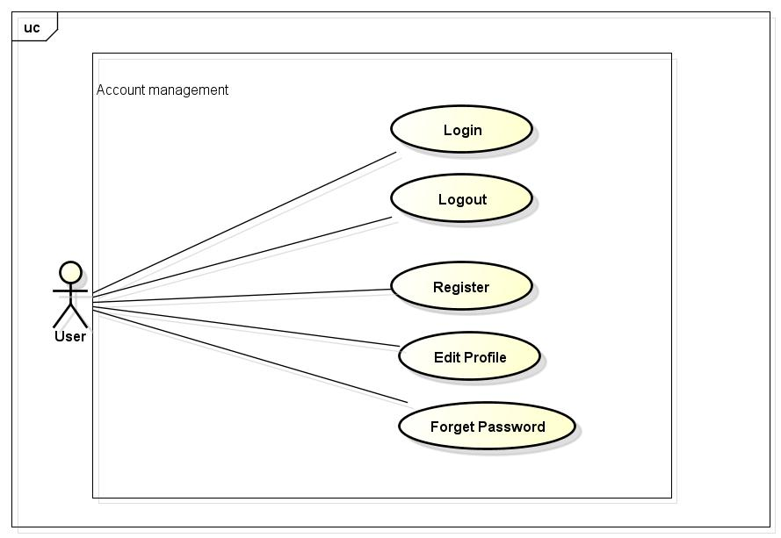

## Login

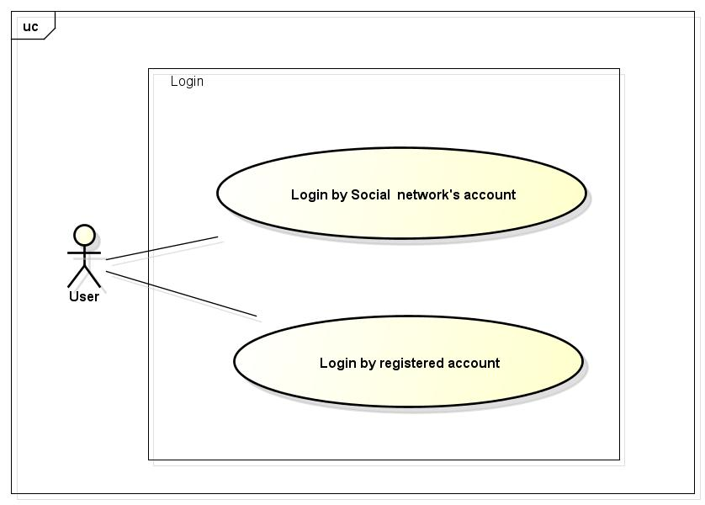

### Login by social network’s account/ registered account

|  |  |  |  |  |
| --- | --- | --- | --- | --- |
| **Use Case ID** | | UC047 | **Version** | 1.1 |
| **Use Case Name** | | Login by social network’s account  Login by registered account | | |
| **Created by:** | | LucPT | **Date Created:** | 28/05/2015 |
| **Primary Actor** | | Registered User | **Secondary Actor** |  |
| **Description:** | | When Member, Administrator want to login by Facebook/Google/Register account to use more functions in website | | |
| **Preconditions:** | | 1. FAP must be connected to the Internet 2. User browsed FAP website 3. Account Facebook/Google/Register must be exist and correctly 4. User are viewing Login page | | |
| **Trigger:** | | User choose the login method, input data and click on Login button | | |
| **Post conditions:** | | 1. Login successfully and redirect user to previous page. | | |
| **Normal Flow** | | | | |
| **Step** | **Actor** | **Action** | | |
| 1 | User | Enter website link on web browser | | |
| 2 | FAP | Display Homepage screen | | |
| 3 | User | Choose login method (Login by Facebook/Google/Register account), input account and password and then click Login button | | |
| 4 | FAP | Validate information and log user into system. | | |
| **Alternative Flows** | | | | |
| **AT1** | At step 3: When user enter data in username and password area then click on another link FAP will switch to selected page | | | |
| **Step** | **Actor** | **Action** | | |
| 3 | FAP | Redirects to selected page. | | |
| **Exceptions:** | | | | |
| **EC1** | The connection is terminated | | | |
| **Step** | **Actor** | **Action** | | |
| 3 | FAP | All fields are cleared and FAP return to the wait state. | | |
|  | | | | |
| **EC2** | At step 3, when user enter wrong user name or password FAP will send message: “Wrong password. Please try again!” | | | |
| **Step** | **Actor** | **Action** | | |
| 3.1 | FAP | Display message “Wrong password. Please try again!” | | |
| 3.2 | FAP | Mark error fields | | |
|  | | | | |
| **EC3** | At step 3, user enter wrong type of email address | | | |
| **Step** | **Actor** | **Action** | | |
| 3.1 | FAP | Display login page with message “The Email field is not a valid e-mail address.” | | |
| 3.2 | FAP | Mark error fields | | |
|  | | | | |
| **Priority** | | High | | |
| **Frequency of Use:** | | High | | |
| **Business Rules:** | | N/A | | |
| **Other Information:** | | N/A | | |

## Logout

|  |  |  |  |  |
| --- | --- | --- | --- | --- |
| **Use Case ID** | | UC048 | **Version** | 1.1 |
| **Use Case Name** | | Logout | | |
| **Created by:** | | LucPT | **Date Created:** | 28/05/2015 |
| **Primary Actor** | | User/ admin | **Secondary Actor** |  |
| **Description:** | | When Member, Admin want to logout their account | | |
| **Preconditions:** | | 1. FAP must be connected to the Internet 2. User browsed FAP website 3. User logged in to system | | |
| **Trigger:** | | Click on logout button | | |
| **Post conditions:** | | 1. Redirect user to previous page. | | |
| **Normal Flow** | | | | |
| **Step** | **Actor** | **Action** | | |
| 1 | User | Click on Logout button | | |
| 2 | FAP | Redirect to homepage | | |
| **Alternative Flows: N/A** | | | | |
| **Exceptions:** | | | | |
| **EC1** | The connection is terminated | | | |
| **Step** | **Actor** | **Action** | | |
| 3 | FAP | FAP return to the wait state. | | |
|  | | | | |
| **Priority** | | High | | |
| **Frequency of Use:** | | High | | |
| **Business Rules:** | | N/A | | |
| **Other Information:** | | N/A | | |

## Register

|  |  |  |  |  |
| --- | --- | --- | --- | --- |
| **Use Case ID** | | UC049 | **Version** | 1.1 |
| **Use Case Name** | | Register | | |
| **Created by:** | | LucPT | **Date Created:** | 28/05/2015 |
| **Primary Actor** | | Guest | **Secondary Actor** |  |
| **Description:** | | Visitor can create new account to use more function as a register user | | |
| **Preconditions:** | | 1. FAP must be connected to the Internet 2. User browsed FAP website | | |
| **Trigger:** | | Click on register link on the website | | |
| **Post conditions:** | | Create account for guest | | |
| **Normal Flow** | | | | |
| **Step** | **Actor** | **Action** | | |
| 1 | User | Enter website link on web browser | | |
| 2 | FAP | Display Homepage screen | | |
| 3 | User | Click on register link | | |
| 4 | FAP | Display register form | | |
| 5 | User | Enter necessary and mandatory information and click Register button. | | |
| 6 | FAP | Display message to register successfully and redirect to homepage | | |
| **Alternative Flows** | | | | |
| **AT1** | At step 4, user click another link | | | |
| **Step** | **Actor** | **Action** | | |
| 4.1 | FAP | Switch to selected page  Clear all fields | | |
| **AT2** | At step 6, User input wrong data | | | |
|  |  |  | | |
|  | | | | |
| **AT3** | At step 3 in the main flow, user clicks on Cancel button | | | |
| **Step** | **Actor** | **Action** | | |
| 3.1 | FAP | Return to previous screen | | |
|  | | | | |
| **Exceptions:** | | | | |
| **EC1** | The connection is terminated | | | |
| **Step** | **Actor** | **Action** | | |
| 3 | FAP | All fields are cleared and FAP return to the wait state. | | |
|  | | | | |
| **EC2** | Missing user name | | | |
| **Step** | **Actor** | **Action** | | |
| 5 | User | Missing “User name” field and click Register button | | |
| 5 | FAP | Display error message beside “password” field. | | |
| 5 | FAP | Mark error fields | | |
|  | | | | |
| **EC3** | Missing password | | | |
| **Step** | **Actor** | **Action** | | |
| 5 | User | Enter incorrect information or missing “password” field and click Register button | | |
| 5 | FAP | Display login page with message “The Email field is not a valid e-mail address.” | | |
| 5 | FAP | Mark error fields | | |
|  | | | | |
| **Priority** | | High | | |
| **Frequency of Use:** | | High | | |
| **Business Rules:** | | N/A | | |
| **Other Information:** | | N/A | | |

## Edit profile

|  |  |  |  |  |
| --- | --- | --- | --- | --- |
| **Use Case ID** | | UC050 | **Version** | 1.1 |
| **Use Case Name** | | Edit profile | | |
| **Created by:** | | LucPT | **Date Created:** | 28/05/2015 |
| **Primary Actor** | | User/Admin | **Secondary Actor** |  |
| **Description:** | | When user want to change their profile | | |
| **Preconditions:** | | 1. FAP must be connected to the Internet 2. User browsed FAP website 3. User logged in to system | | |
| **Trigger:** | | User login the website and click on the edit profile link | | |
| **Post conditions:** | | User’s profile is edited successfully | | |
| **Normal Flow** | | | | |
| **Step** | **Actor** | **Action** | | |
| 1 | User | Enter website link on web browser | | |
| 2 | FAP | Display Homepage screen | | |
| 3 | User | Enter necessary and mandatory information and click Login | | |
| 4 | FAP | Redirect to previous page and logged user into system. | | |
| 5 | User | Click on Personal link. | | |
| 6 | FAP | Display “Personal” page | | |
| 7 | User | User changes profile and click Save button | | |
| 8 | FAP | Update new profile | | |
| **Alternative Flows** | | | | |
| **AT1** | At step 4, user click another link | | | |
| **Step** | **Actor** | **Action** | | |
| 4.1 | FAP | Switch to selected page  Clear all fields | | |
|  | | | | |
| **AT2** | At step 3 in the main flow, user clicks on Cancel button | | | |
| **Step** | **Actor** | **Action** | | |
| 3.1 | FAP | Return to previous screen | | |
|  | | | | |
| **Exceptions:** | | | | |
| **EC1** | The connection is terminated | | | |
| **Step** | **Actor** | **Action** | | |
| 3 | FAP | All fields are cleared and FAP return to the wait state. | | |
|  | | | | |
| **EC2** |  | | | |
| **Step** | **Actor** | **Action** | | |
| 7 | User | Enter new password that incorrect form or missing information and click Save button | | |
| 8 | FAP | Display error message | | |
|  | | | | |
| **EC3** |  | | | |
| **Step** | **Actor** | **Action** | | |
| 7 | User | Enter new email that incorrect form or missing information and click Save button | | |
| 8 | FAP | Display error message | | |
|  | | | | |
| **Priority** | | High | | |
| **Frequency of Use:** | | High | | |
| **Business Rules:** | | N/A | | |
| **Other Information:** | | N/A | | |

## Forgot password

|  |  |  |  |  |
| --- | --- | --- | --- | --- |
| **Use Case ID** | | UC051 | **Version** | 1.1 |
| **Use Case Name** | | Forgot password | | |
| **Created by:** | | LucPT | **Date Created:** | 28/05/2015 |
| **Primary Actor** | | User/admin | **Secondary Actor** |  |
| **Description:** | | When Member, Admin forgot their password to login the system, this function will receiving their password to email | | |
| **Preconditions:** | | 1. FAP must be connected to the Internet 2. User browsed FAP website 3. User logged in to system | | |
| **Trigger:** | | Click on forgot password link on the website | | |
| **Post conditions:** | | User receive their password to their email | | |
| **Normal Flow** | | | | |
| **Step** | **Actor** | **Action** | | |
| 1 | User | Enter website link on web browser | | |
| 2 | FAP | Display Homepage screen | | |
| 3 | User | Click on “Forgot password” link | | |
| 4 | FAP | Display “Forgot password” page | | |
| 5 | User | Enter necessary and mandatory information in the “Forgot password” form and click Send request button. | | |
| 6 | FAP | System will send the password into user’s email | | |
| **Alternative Flows** | | | | |
| **AT1** | At step 4, user click another link | | | |
| **Step** | **Actor** | **Action** | | |
| 4.1 | FAP | Switch to selected page and clear all fields | | |
|  | | | | |
| **AT2** | At step 3 in the main flow, user clicks on Cancel button | | | |
| **Step** | **Actor** | **Action** | | |
| 3.1 | FAP | Return to previous screen | | |
|  | | | | |
| **Exceptions:** | | | | |
| **EC1** | The connection is terminated | | | |
| **Step** | **Actor** | **Action** | | |
| 3 | FAP | All fields are cleared and FAP return to the wait state. | | |
|  | | | | |
| **EC2** |  | | | |
| **Step** | **Actor** | **Action** | | |
| 5 | User | Enter email incorrect with email that use to register account | | |
| 6 | FAP | Display error message and request to re-enter email | | |
|  | | | | |
| **Priority** | | High | | |
| **Frequency of Use:** | | High | | |
| **Business Rules:** | | N/A | | |
| **Other Information:** | | N/A | | |

## Admin Module

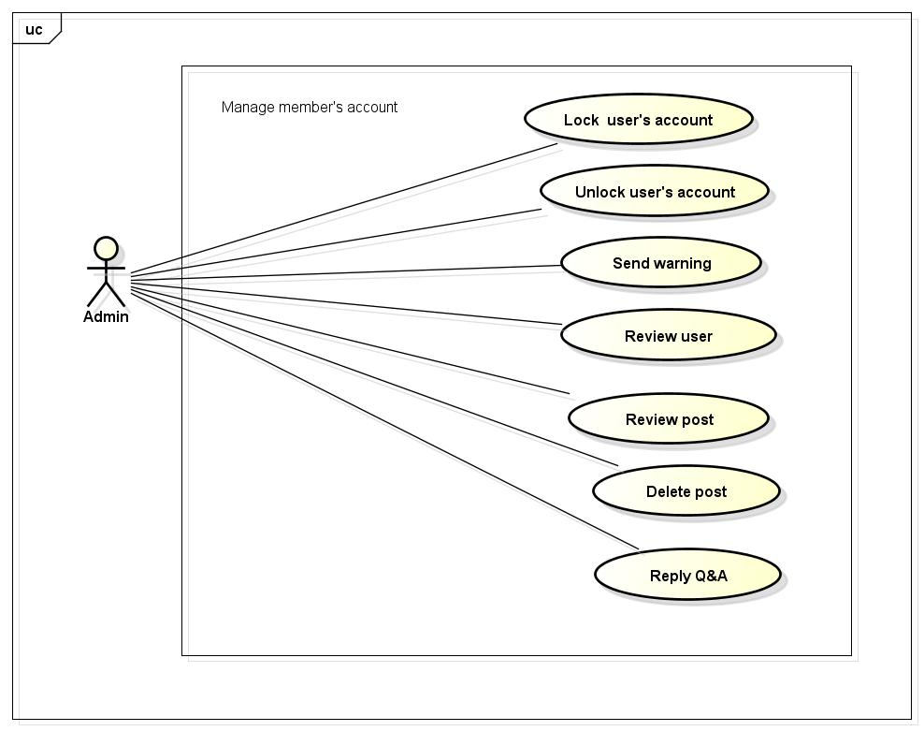

## Lock user’s account

|  |  |  |  |  |
| --- | --- | --- | --- | --- |
| **Use Case ID** | | UC052 | **Version** | 1.1 |
| **Use Case Name** | | Lock user’s account | | |
| **Created by:** | | LucPT | **Date Created:** | 28/05/2015 |
| **Primary Actor** | | Admin | **Secondary Actor** | None |
| **Description:** | | Administrator can lock user account in a period of time depending on severity | | |
| **Preconditions:** | | 1. FAP must be connected to the Internet 2. Admin browsed FAP website 3. Admin logged in to system | | |
| **Trigger:** | | Admin login the website and click on member’s account and then click Lock button | | |
| **Post conditions:** | | Member’s account will be locked by administrator | | |
| **Normal Flow** | | | | |
| **Step** | **Actor** | **Action** | | |
| 1 | Admin | Enter website link on web browser | | |
| 2 | FAP | Display Homepage screen | | |
| 3 | Admin | Administrator enter necessary and mandatory information and click Login | | |
| 4 | FAP | Display homepage screen | | |
| 5 | Admin | Administrator click on Search member button and input member’s account or email. | | |
| 6 | Admin | Administrator click Lock link | | |
| 7 | FAP | FAP will lock member | | |
| **Alternative Flows** | | | | |
| **AT1** |  | | | |
| **Step** | **Actor** | **Action** | | |
| 5 | Admin | Administrator fill information of the member that they want to find into these fields then click on another link | | |
| 6 | FAP | Will switch to selected page | | |
| **Exceptions:** | | | | |
| **EC1** | The connection is terminated | | | |
| **Step** | **Actor** | **Action** | | |
| 3 | FAP | All fields are cleared and FAP return to the wait state. | | |
|  | | | | |
| **EC2** |  | | | |
| **Step** | **Actor** | **Action** | | |
| 5 | Admin | Administrator fill information of the member that they want to find (that do not exist in database) into these fields then click Search button. | | |
| 6 | FAP | Return Error message to inform that member cannot be found | | |
|  | | | | |
| **Priority** | | High | | |
| **Frequency of Use:** | | High | | |
| **Business Rules:** | | N/A | | |
| **Other Information:** | | N/A | | |

## Unlock user’s account

|  |  |  |  |  |
| --- | --- | --- | --- | --- |
| **Use Case ID** | | UC053 | **Version** | 1.1 |
| **Use Case Name** | | Unlock user’s account | | |
| **Created by:** | | LucPT | **Date Created:** | 28/05/2015 |
| **Primary Actor** | | Admin | **Secondary Actor** |  |
| **Description:** | | Administrator can unlock user account | | |
| **Preconditions:** | | 1. Website is available 2. Admin must be login 3. This user must have been locked | | |
| **Trigger:** | | Admin login the website and click on member’s account and then click Unlock button | | |
| **Post conditions:** | | Member’s account will be unlock by administrator | | |
| **Normal Flow** | | | | |
| **Step** | **Actor** | **Action** | | |
| 1 | Admin | Enter website link on web browser | | |
| 2 | FAP | Display Homepage screen | | |
| 3 | Admin | Administrator enter necessary and mandatory information and click Login | | |
| 4 | FAP | Display homepage screen | | |
| 5 | Admin | Administrator click on Search member button and input member’s account or email. | | |
| 6 | Admin | Administrator click Unlock link | | |
| 7 | FAP | FAP will unlock member | | |
| **Alternative Flows** | | | | |
| **AT1** |  | | | |
| **Step** | **Actor** | **Action** | | |
| 5 | Admin | Administrator fill information of the member that they want to find into these fields then click on another link | | |
| 6 | FAP | Switch to selected page | | |
| **Exceptions:** | | | | |
| **EC1** | The connection is terminated | | | |
| **Step** | **Actor** | **Action** | | |
| 3 | FAP | All fields are cleared and FAP return to the wait state. | | |
|  | | | | |
| **EC2** |  | | | |
| **Step** | **Actor** | **Action** | | |
| 5 | Admin | Administrator fill information of the member that they want to find (that do not exist in database) into these fields then click Search button. | | |
| 6 | FAP | Return Error message to inform that member cannot be found | | |
|  | | | | |
| **Priority** | | High | | |
| **Frequency of Use:** | | High | | |
| **Business Rules:** | | N/A | | |
| **Other Information:** | | N/A | | |

## Send warning

|  |  |  |  |  |
| --- | --- | --- | --- | --- |
| **Use Case ID** | | UC054 | **Version** | 1.1 |
| **Use Case Name** | | Send warning | | |
| **Created by:** | | LucPT | **Date Created:** | 28/05/2015 |
| **Primary Actor** | | Admin | **Secondary Actor** |  |
| **Description:** | | Administrator can warn user when they violate some rule of website but just quite small | | |
| **Preconditions:** | | 1. FAP must be connected to the Internet 2. Admin browsed FAP website 3. Admin logged in to system 4. User is reported | | |
| **Trigger:** | | Admin login the website and click on member’s account and then click send message. | | |
| **Post conditions:** | | Member’s account will be worn by administrator | | |
| **Normal Flow** | | | | |
| **Step** | **Actor** | **Action** | | |
| 1 | Admin | Enter website link on web browser | | |
| 2 | FAP | Display Homepage screen | | |
| 3 | Admin | Administrator enter necessary and mandatory information and click Login | | |
| 4 | FAP | Display homepage screen | | |
| 5 | Admin | Administrator click on Search member button and input member’s account or email. | | |
| 6 | Admin | Administrator click send message | | |
| 7 | FAP | FAP will send message to user. | | |
| **Alternative Flows** | | | | |
| **AT1** |  | | | |
| **Step** | **Actor** | **Action** | | |
| 5 | Admin | Administrator fill information of the member that they want to find into these fields then click on another link | | |
| 6 | FAP | Will switch to selected page | | |
|  | | | | |
| **Exceptions:** | | | | |
| **EC1** | The connection is terminated | | | |
| **Step** | **Actor** | **Action** | | |
| 3 | FAP | All fields are cleared and FAP return to the wait state. | | |
|  | | | | |
| **EC2** |  | | | |
| **Step** | **Actor** | **Action** | | |
| 5 | Admin | Administrator fill information of the member that they want to find (that do not exist in database) into these fields then click Search button. | | |
| 6 | FAP | Return Error message to inform that member cannot be found | | |
|  | | | | |
| **Priority** | | High | | |
| **Frequency of Use:** | | High | | |
| **Business Rules:** | | N/A | | |
| **Other Information:** | | N/A | | |

## Review user

|  |  |  |  |  |
| --- | --- | --- | --- | --- |
| **Use Case ID** | | UC055 | **Version** | 1.1 |
| **Use Case Name** | | Review user | | |
| **Created by:** | | LucPT | **Date Created:** | 28/05/2015 |
| **Primary Actor** | | Admin | **Secondary Actor** |  |
| **Description:** | | Review reported user | | |
| **Preconditions:** | | 1. FAP must be connected to the Internet 2. Admin browsed FAP website 3. Admin logged in to system 4. User is reported | | |
| **Trigger:** | | Administrator login the website and review user who has been reported | | |
| **Post conditions:** | | Member’s account will be review by administrator | | |
| **Normal Flow** | | | | |
| **Step** | **Actor** | **Action** | | |
| 1 | Admin | Enter website link on web browser | | |
| 2 | FAP | Display Homepage screen | | |
| 3 | Admin | Administrator enter necessary and mandatory information and click Login | | |
| 4 | FAP | Display homepage screen | | |
| 5 | Admin | Administrator click on Search member button and input member’s account or email. | | |
| **Alternative Flows** | | | | |
| **AT1** |  | | | |
| **Step** | **Actor** | **Action** | | |
| 5 | Admin | Administrator fill information of the member that they want to find into these fields then click on another link | | |
| 6 | FAP | Will switch to selected page | | |
| **Exceptions:** | | | | |
| **EC1** | The connection is terminated | | | |
| **Step** | **Actor** | **Action** | | |
| 3 | FAP | All fields are cleared and FAP return to the wait state. | | |
|  | | | | |
| **EC2** |  | | | |
| **Step** | **Actor** | **Action** | | |
| 5 | Admin | Administrator fill information of the member that they want to find (that do not exist in database) into these fields then click Search button. | | |
| 6 | FAP | Return Error message to inform that member cannot be found | | |
|  | | | | |
| **Priority** | | High | | |
| **Frequency of Use:** | | High | | |
| **Business Rules:** | | N/A | | |
| **Other Information:** | | N/A | | |

## Review post

|  |  |  |  |  |
| --- | --- | --- | --- | --- |
| **Use Case ID** | | UC056 | **Version** | 1.1 |
| **Use Case Name** | | Review post | | |
| **Created by:** | | LucPT | **Date Created:** | 28/05/2015 |
| **Primary Actor** | | Admin | **Secondary Actor** |  |
| **Description:** | | Review reported post | | |
| **Preconditions:** | | 1. FAP must be connected to the Internet 2. Admin browsed FAP website 3. Admin logged in to system 4. Post is reported | | |
| **Trigger:** | | Administrator login the website and review post which has been reported | | |
| **Post conditions:** | | Member’s post will be review by administrator | | |
| **Normal Flow** | | | | |
| **Step** | **Actor** | **Action** | | |
| 1 | Admin | Enter website link on web browser | | |
| 2 | FAP | Display Homepage screen | | |
| 3 | Admin | Administrator enter necessary and mandatory information and click Login | | |
| 4 | FAP | Display homepage screen | | |
| 5 | Admin | Administrator click on Search member button and input member’s account or email. | | |
| 6 | Admin | Administrator finds post and review | | |
| **Alternative Flows** | | | | |
| **AT1** |  | | | |
| **Step** | **Actor** | **Action** | | |
| 5 | Admin | Administrator fill information of the member that they want to find into these fields then click on another link | | |
| 6 | FAP | Will switch to selected page | | |
| **Exceptions:** | | | | |
| **EC1** | The connection is terminated | | | |
| **Step** | **Actor** | **Action** | | |
| 3 | FAP | All fields are cleared and FAP return to the wait state. | | |
|  | | | | |
| **EC2** |  | | | |
| **Step** | **Actor** | **Action** | | |
| 5 | Admin | Administrator fill information of the member that they want to find (that do not exist in database) into these fields then click Search button. | | |
| 6 | FAP | Return Error message to inform that member cannot be found | | |
|  | | | | |
| **Priority** | | High | | |
| **Frequency of Use:** | | High | | |
| **Business Rules:** | | N/A | | |
| **Other Information:** | | N/A | | |

## Delete user’s post

|  |  |  |  |  |
| --- | --- | --- | --- | --- |
| **Use Case ID** | | UC057 | **Version** | 1.1 |
| **Use Case Name** | | Delete post | | |
| **Created by:** | | LucPT | **Date Created:** | 28/05/2015 |
| **Primary Actor** | | Admin | **Secondary Actor** |  |
| **Description:** | | Administrator can delete post when this post violate rule of website | | |
| **Preconditions:** | | 1. FAP must be connected to the Internet 2. Admin browsed FAP website 3. Admin logged in to system 4. Post violated rule(s) | | |
| **Trigger:** | | Administrator login the website and review post which has been reported | | |
| **Post conditions:** | | Member’s post will be review by administrator | | |
| **Normal Flow** | | | | |
| **Step** | **Actor** | **Action** | | |
| 1 | Admin | Enter website link on web browser | | |
| 2 | FAP | Display Homepage screen | | |
| 3 | Admin | Administrator enter necessary and mandatory information and click Login | | |
| 4 | FAP | display homepage screen | | |
| 5 | Admin | Administrator click on Search member button and input member’s account or email. | | |
| 6 | Admin | Administrator finds post and review | | |
| 7 | Admin | Admin click delete button | | |
| 8 | FAP | FAP delete post | | |
| **Alternative Flows** | | | | |
| **AT1** |  | | | |
| **Step** | **Actor** | **Action** | | |
| 5 | Admin | Administrator fill information of the member that they want to find into these fields then click on another link | | |
| 6 | FAP | Will switch to selected page | | |
| **Exceptions:** | | | | |
| **EC1** | The connection is terminated | | | |
| **Step** | **Actor** | **Action** | | |
| 3 | FAP | All fields are cleared and FAP return to the wait state. | | |
|  | | | | |
| **EC2** |  | | | |
| **Step** | **Actor** | **Action** | | |
| 5 | Admin | Administrator fill information of the member that they want to find (that do not exist in database) into these fields then click Search button. | | |
| 6 | FAP | Return Error message to inform that member cannot be found | | |
|  | | | | |
| **Priority** | | High | | |
| **Frequency of Use:** | | High | | |
| **Business Rules:** | | N/A | | |
| **Other Information:** | | N/A | | |

## Reply question

|  |  |  |  |  |
| --- | --- | --- | --- | --- |
| **Use Case ID** | | UC058 | **Version** | 1.1 |
| **Use Case Name** | | Reply question | | |
| **Created by:** | | LucPT | **Date Created:** | 28/05/2015 |
| **Primary Actor** | | Admin | **Secondary Actor** |  |
| **Description:** | | Reply question of user or guest. | | |
| **Preconditions:** | | 1. FAP must be connected to the Internet 2. Admin browsed FAP website 3. Admin logged in to system | | |
| **Trigger:** | | Click on “Opinion/Q&A Management ” tab, User search question then click Reply link corresponding | | |
| **Post conditions:** | | Answer is sent to user | | |
| **Normal Flow** | | | | |
| **Step** | **Actor** | **Action** | | |
| 1 | Admin | Enter website link on web browser | | |
| 2 | FAP | Display Homepage screen | | |
| 3 | Admin | Administrator enter necessary and mandatory information and click Login | | |
| 4 | FAP | Display homepage screen | | |
| 5 | Admin | Admin click Reply link corresponding | | |
| 6 | User | Displays Reply screen with these elements: Contact_Content, Contact_Email, Answer | | |
| 7 | Admin | Administrator enter the answer | | |
| 8 | Admin | Administrator click Reply button | | |
| 9 | FAP | FAP sent answer to member. | | |
| **Alternative Flows** | | | | |
| **AT1** |  | | | |
| **Step** | **Actor** | **Action** | | |
| 5 | Admin | Administrator fill information of the member that they want to find into these fields then click on another link | | |
| 6 | FAP | Will switch to selected page | | |
| **Exceptions:** | | | | |
| **EC1** | The connection is terminated | | | |
| **Step** | **Actor** | **Action** | | |
| 3 | FAP | All fields are cleared and FAP return to the wait state. | | |
|  | | | | |
| **EC2** |  | | | |
| **Step** | **Actor** | **Action** | | |
| 8 | Admin | Administrator answer then click on another link | | |
| 8 | FAP | FAP switch to selected page | | |
|  | | | | |
| **Priority** | | High | | |
| **Frequency of Use:** | | High | | |
| **Business Rules:** | | N/A | | |
| **Other Information:** | | N/A | | |

# **NON-FUNCTIONAL SPECIFICATION**

### Reliability

1. Mean time between failures: The mean time between each failure is expected to be about 480 hours of using.
2. Mean time to repair: Immediately when Administrator finds out problem or website is attacked/hacked by someone. Average 1 day.
3. The maximum bugs per function are 2 bugs/a function when user uses software within 2 months. The average number of bugs in the software during system testing is about to be around 1 bugs/1000 LOC.
4. The database must be backed up daily and can be recovered if necessary

### Performance Requirements

#### Availability

The application must be available 95% of time. Users can access to it everywhere from their

Web browser with internet connection.

#### Response time

In term of response time, waiting time of processing will be 2 to 5 seconds; time to process any functions will not exceed 7 seconds.

### User Interface

● **Color:** The background color will be white and blue in default. The color of text will be black or white.

● **Text:** All texts bases on Helvetica style and title or label will use upper case with the first letter.

### Maintainability

* **Coding standards and naming conventions**
  + Output of the project must include coding standards and naming conventions documentations. Implementation code must be easy to maintain.
  + All code must be clearly commented, including class, method documentations.
  + If some components are reused, the documentations of those components must also be included.
* **Design**
  + The design of the system must be loosely coupled that chances on some module will not affect others.
* **Logging**
  + All the errors should be logged, supporting for bug fixing and maintenance.
  + All strange or sensitive situations should also be logged.

### Usability

Usability Requirements support the following from the perspective of its primary users:

● **Efficiency of use:** user can complete each function in less than 12 actions

● **Intuitiveness:** all help/error messages are simple to understand; user can know exactly how to do each feature after one time using it.

### Security Requirements

In order to avoid unwanted access by strangers, the security implemented in various ways:

1. **User layer**: Each function must be distributed system access and manipulate the individual parts. To edit information, user must declare their username and password before the operation. Functions will be show after users login dependencies user’s role and permission of each user.
2. **Manage Data Layer**: Only Administrator can modify database system.
3. **Stored Data**: All data about information of user, tested...will be saved in SQL Server, and be easy for data classification or backup...

### Hardware/Software Requirements

● **Hardware requirement:** PC/Laptop (window 7, window 8, window XP…)

● **Software requirements:** Web browser (Chrome, Firefox, IE…) with internet connection